Lab 1

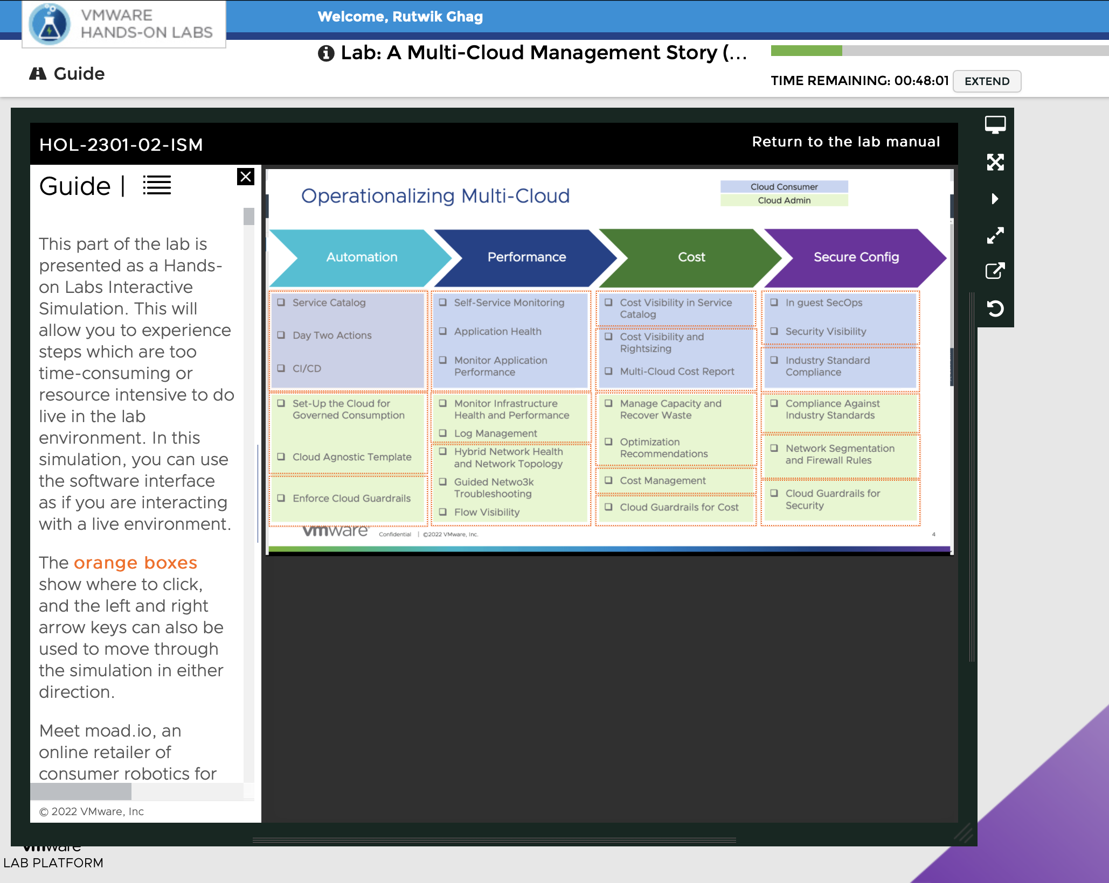

Entering VMware simulation

Automation for cloud consumer:

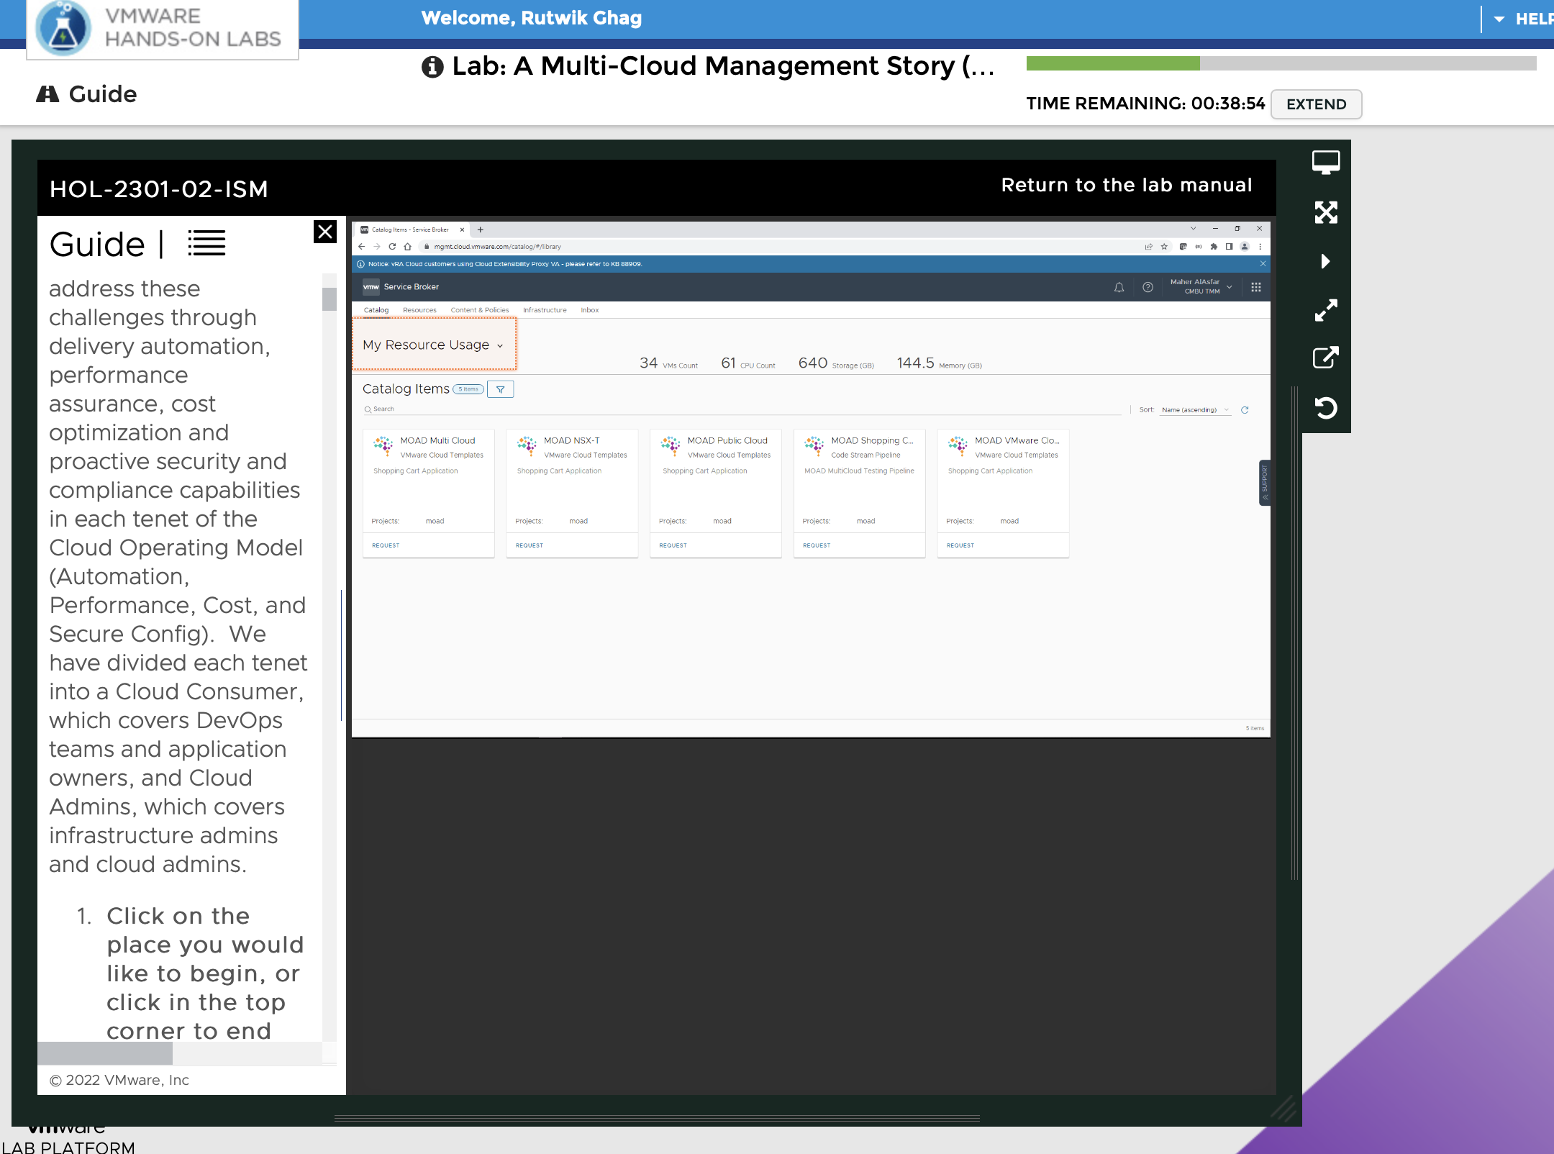

Launched VMware Service Broker

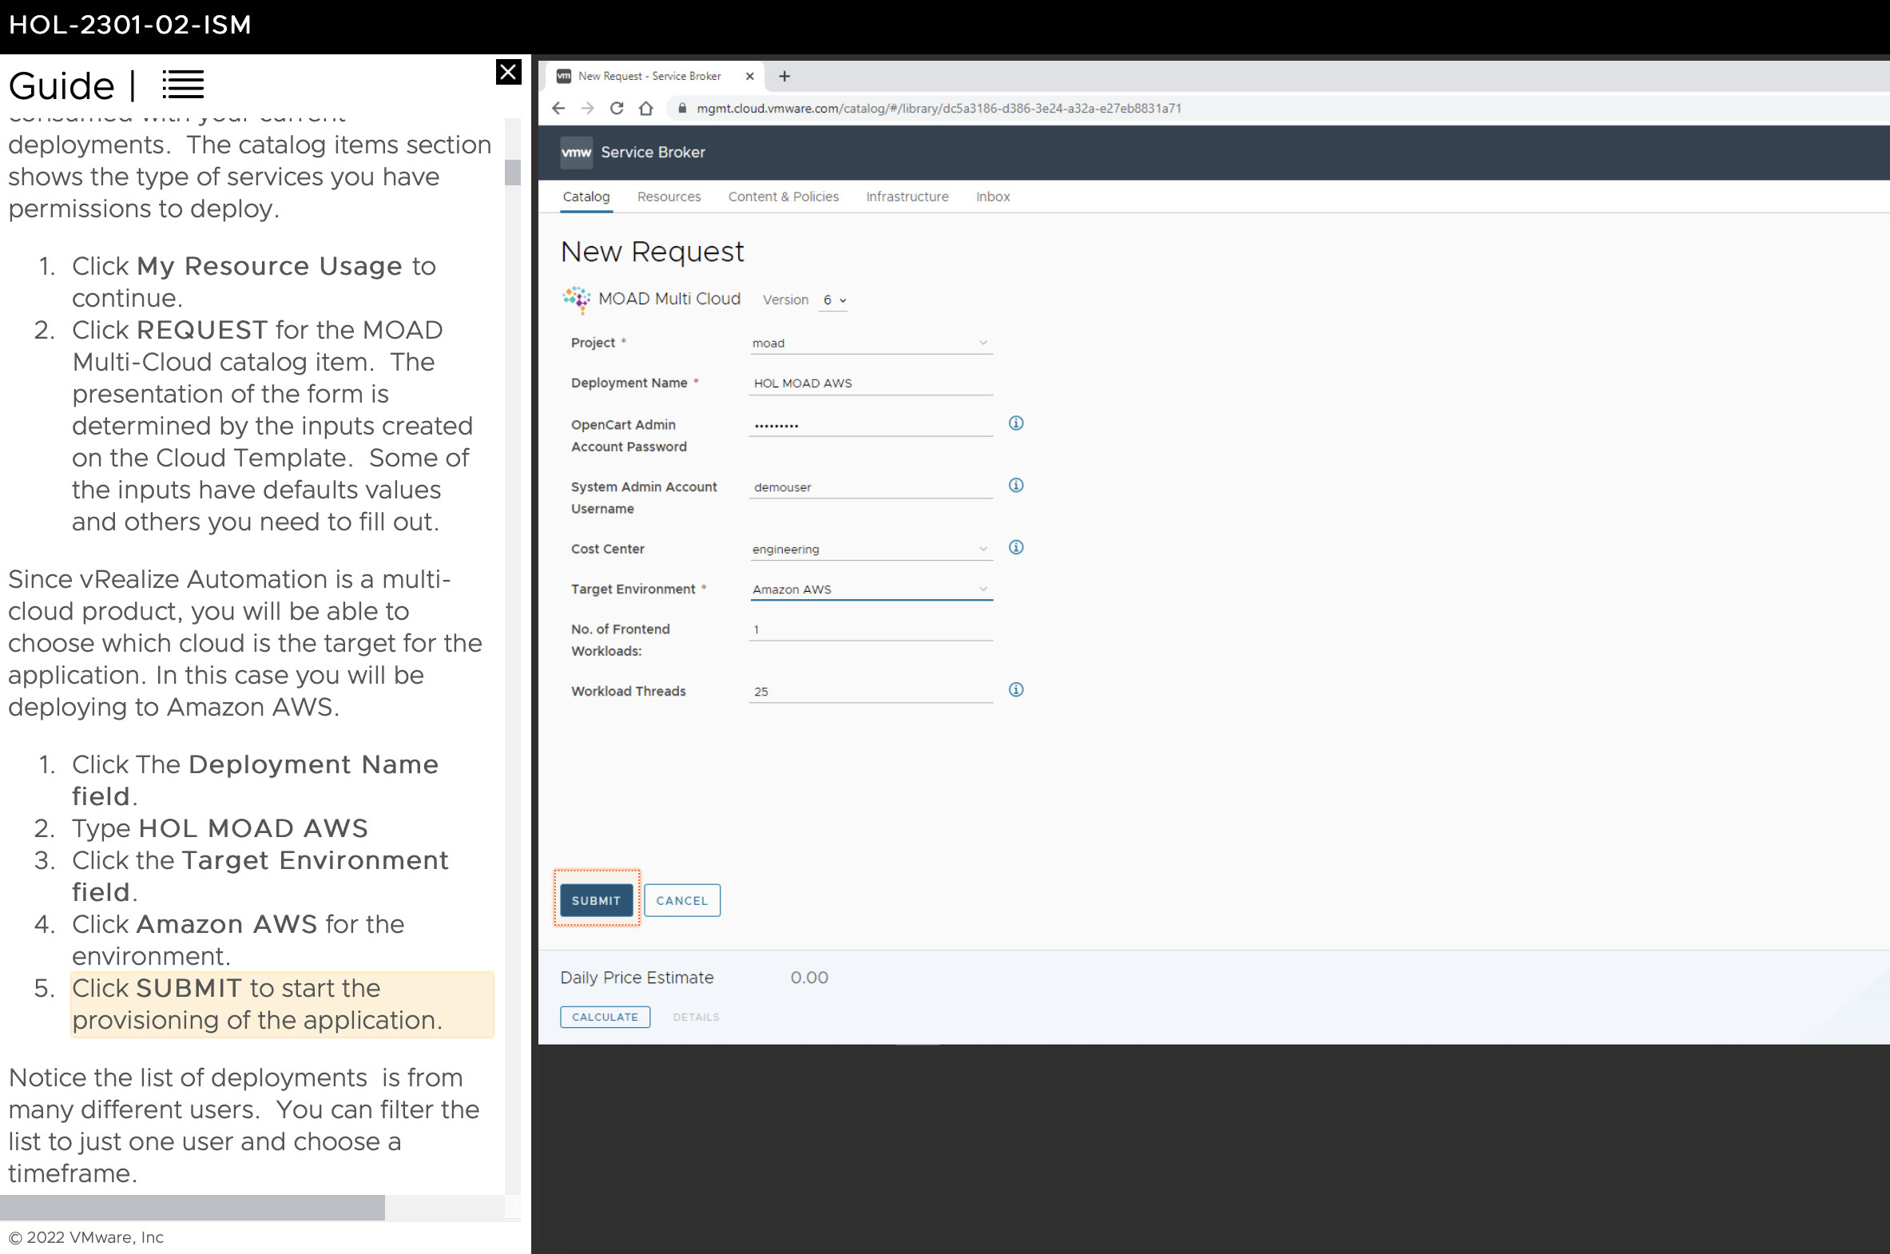

Submitting form to start provisioning of the application

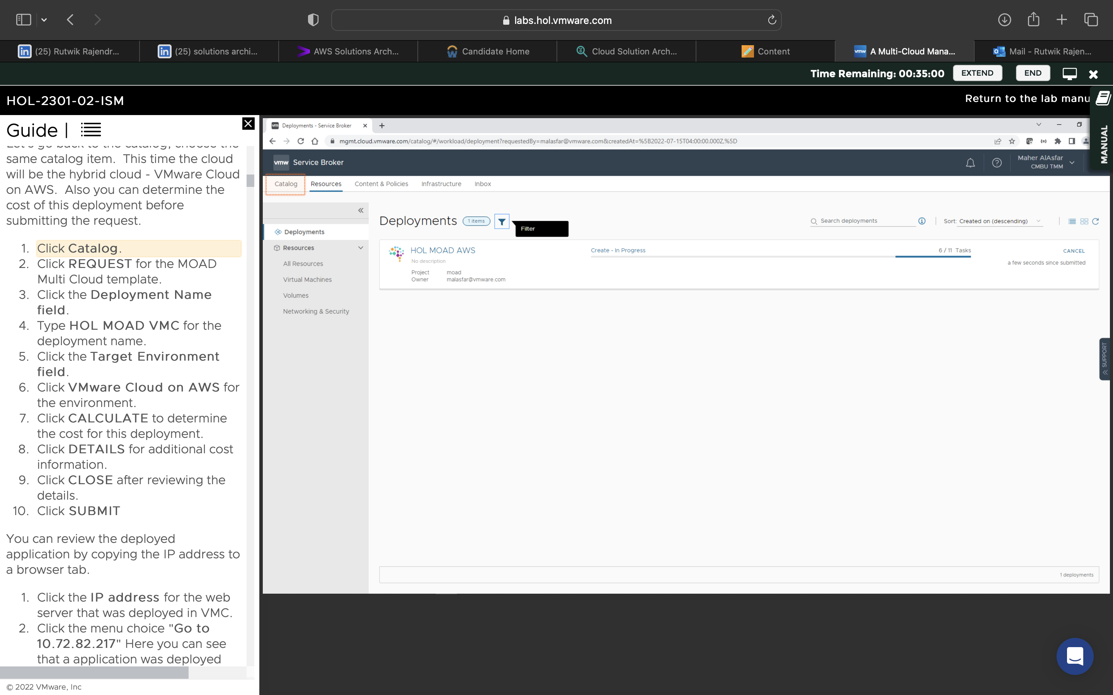

Completed filters

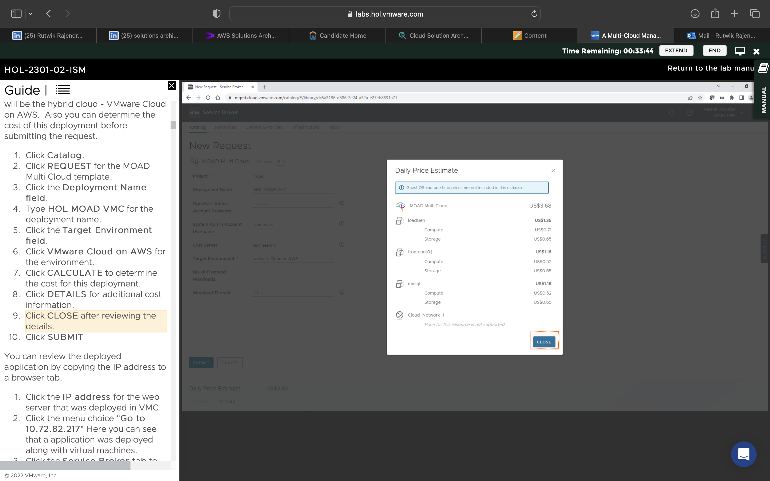

Calculated and reviewed costs of VMware cloud on AWS

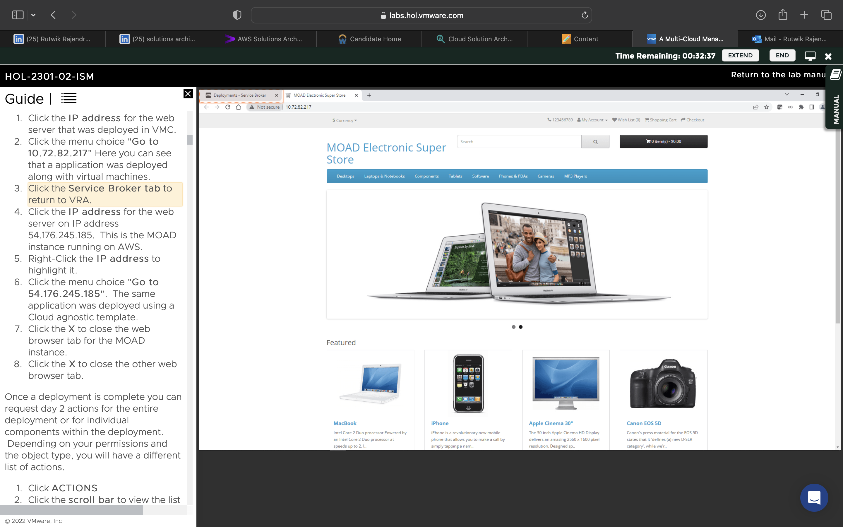

Checking if application is deployed

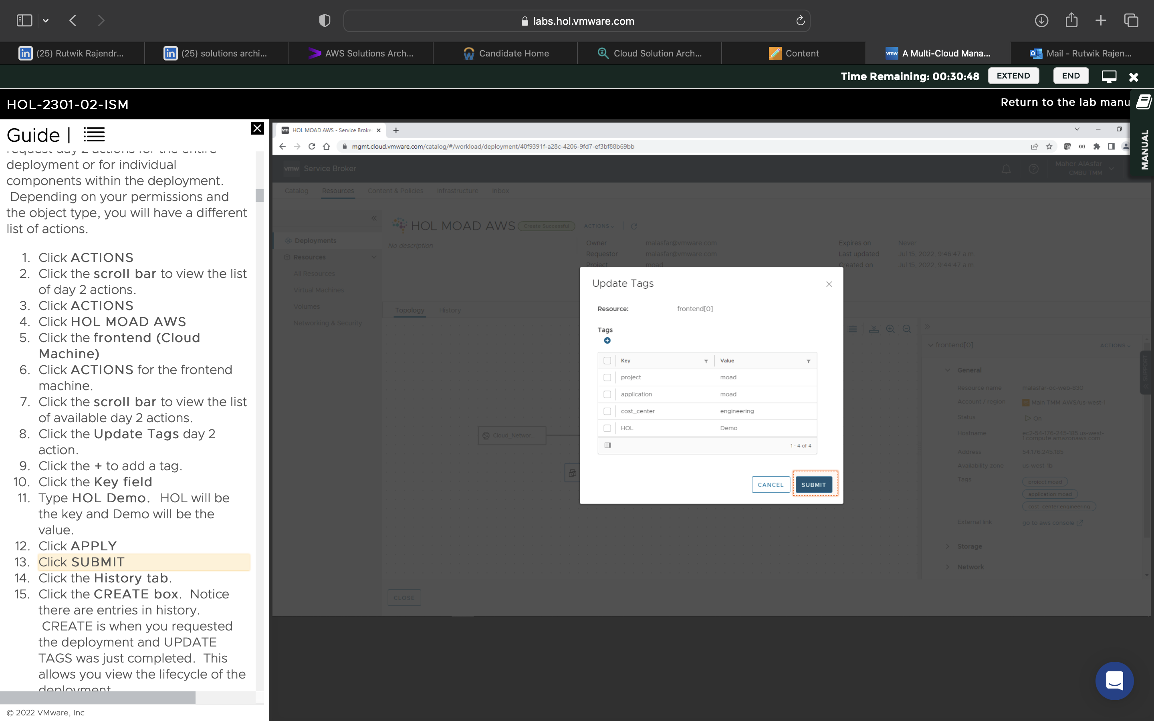

Updating tags for the frontend

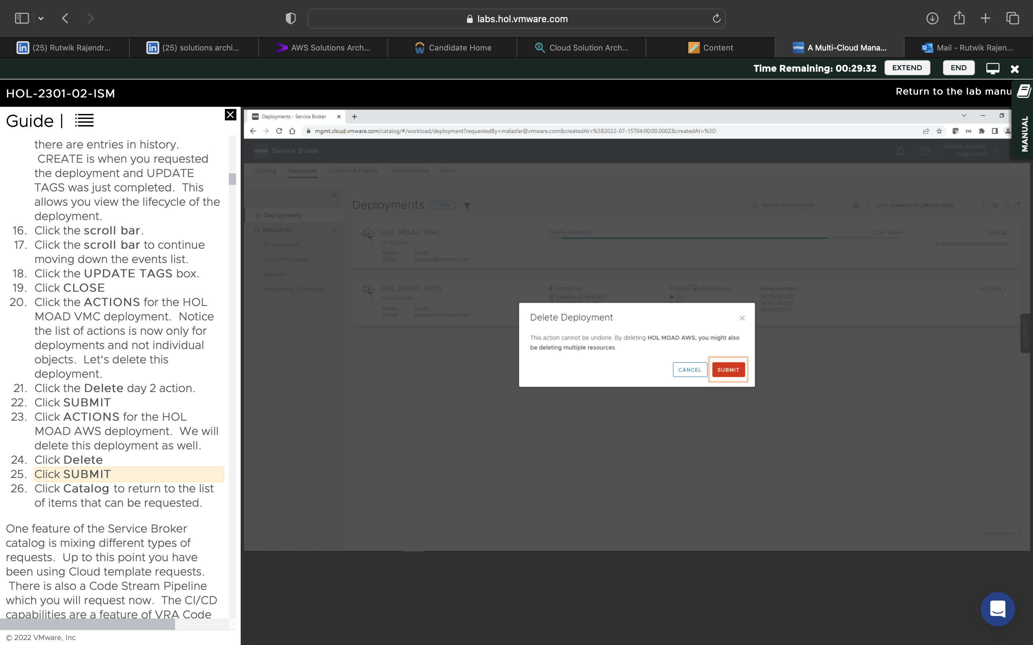

Deleting the day 2 actions for the deployments

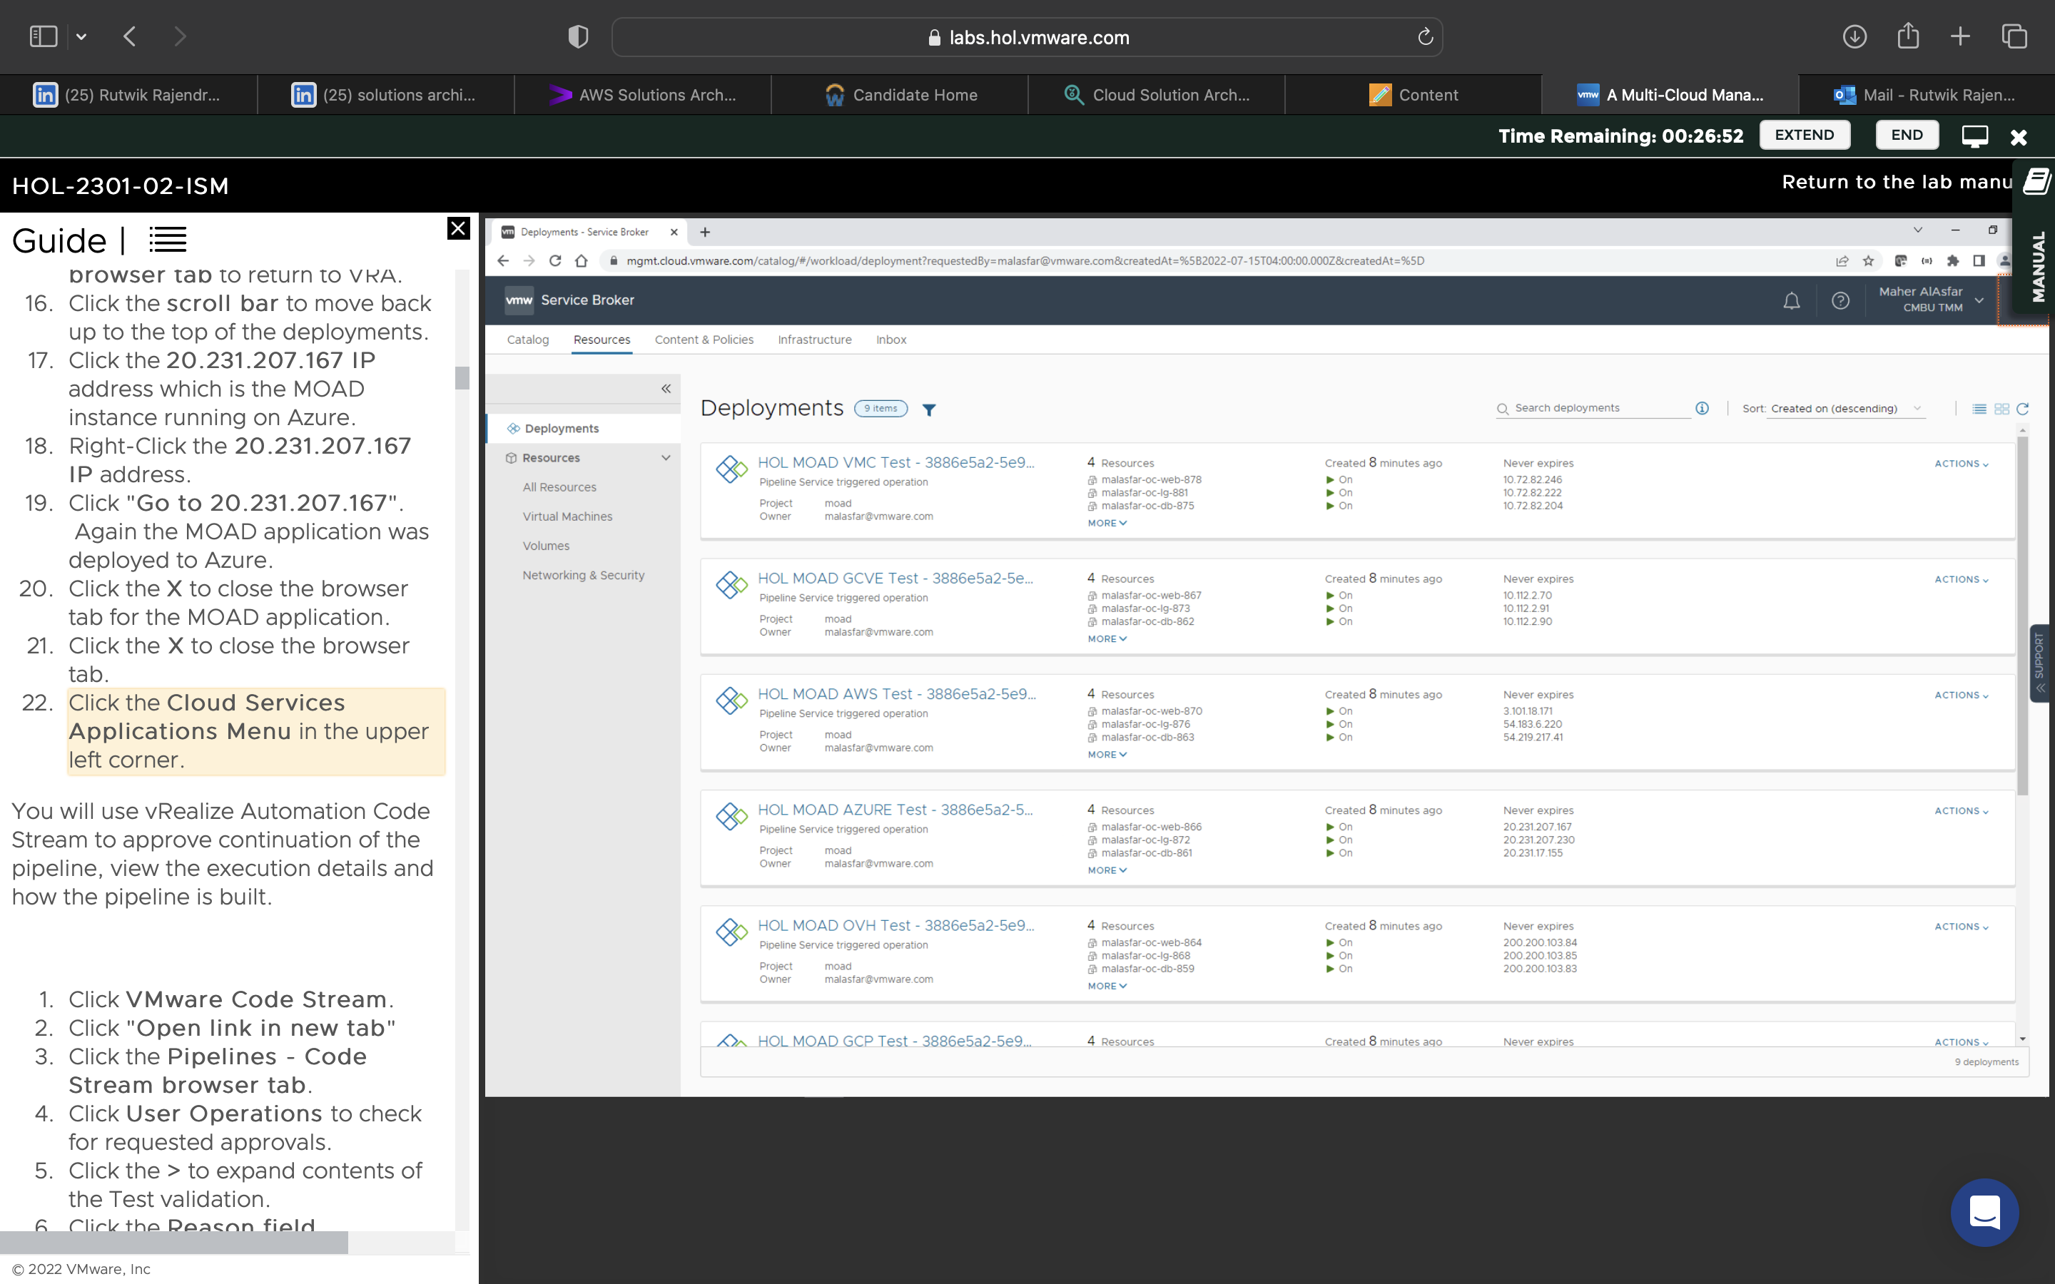

Viewed the websites and shopping cart capabilities

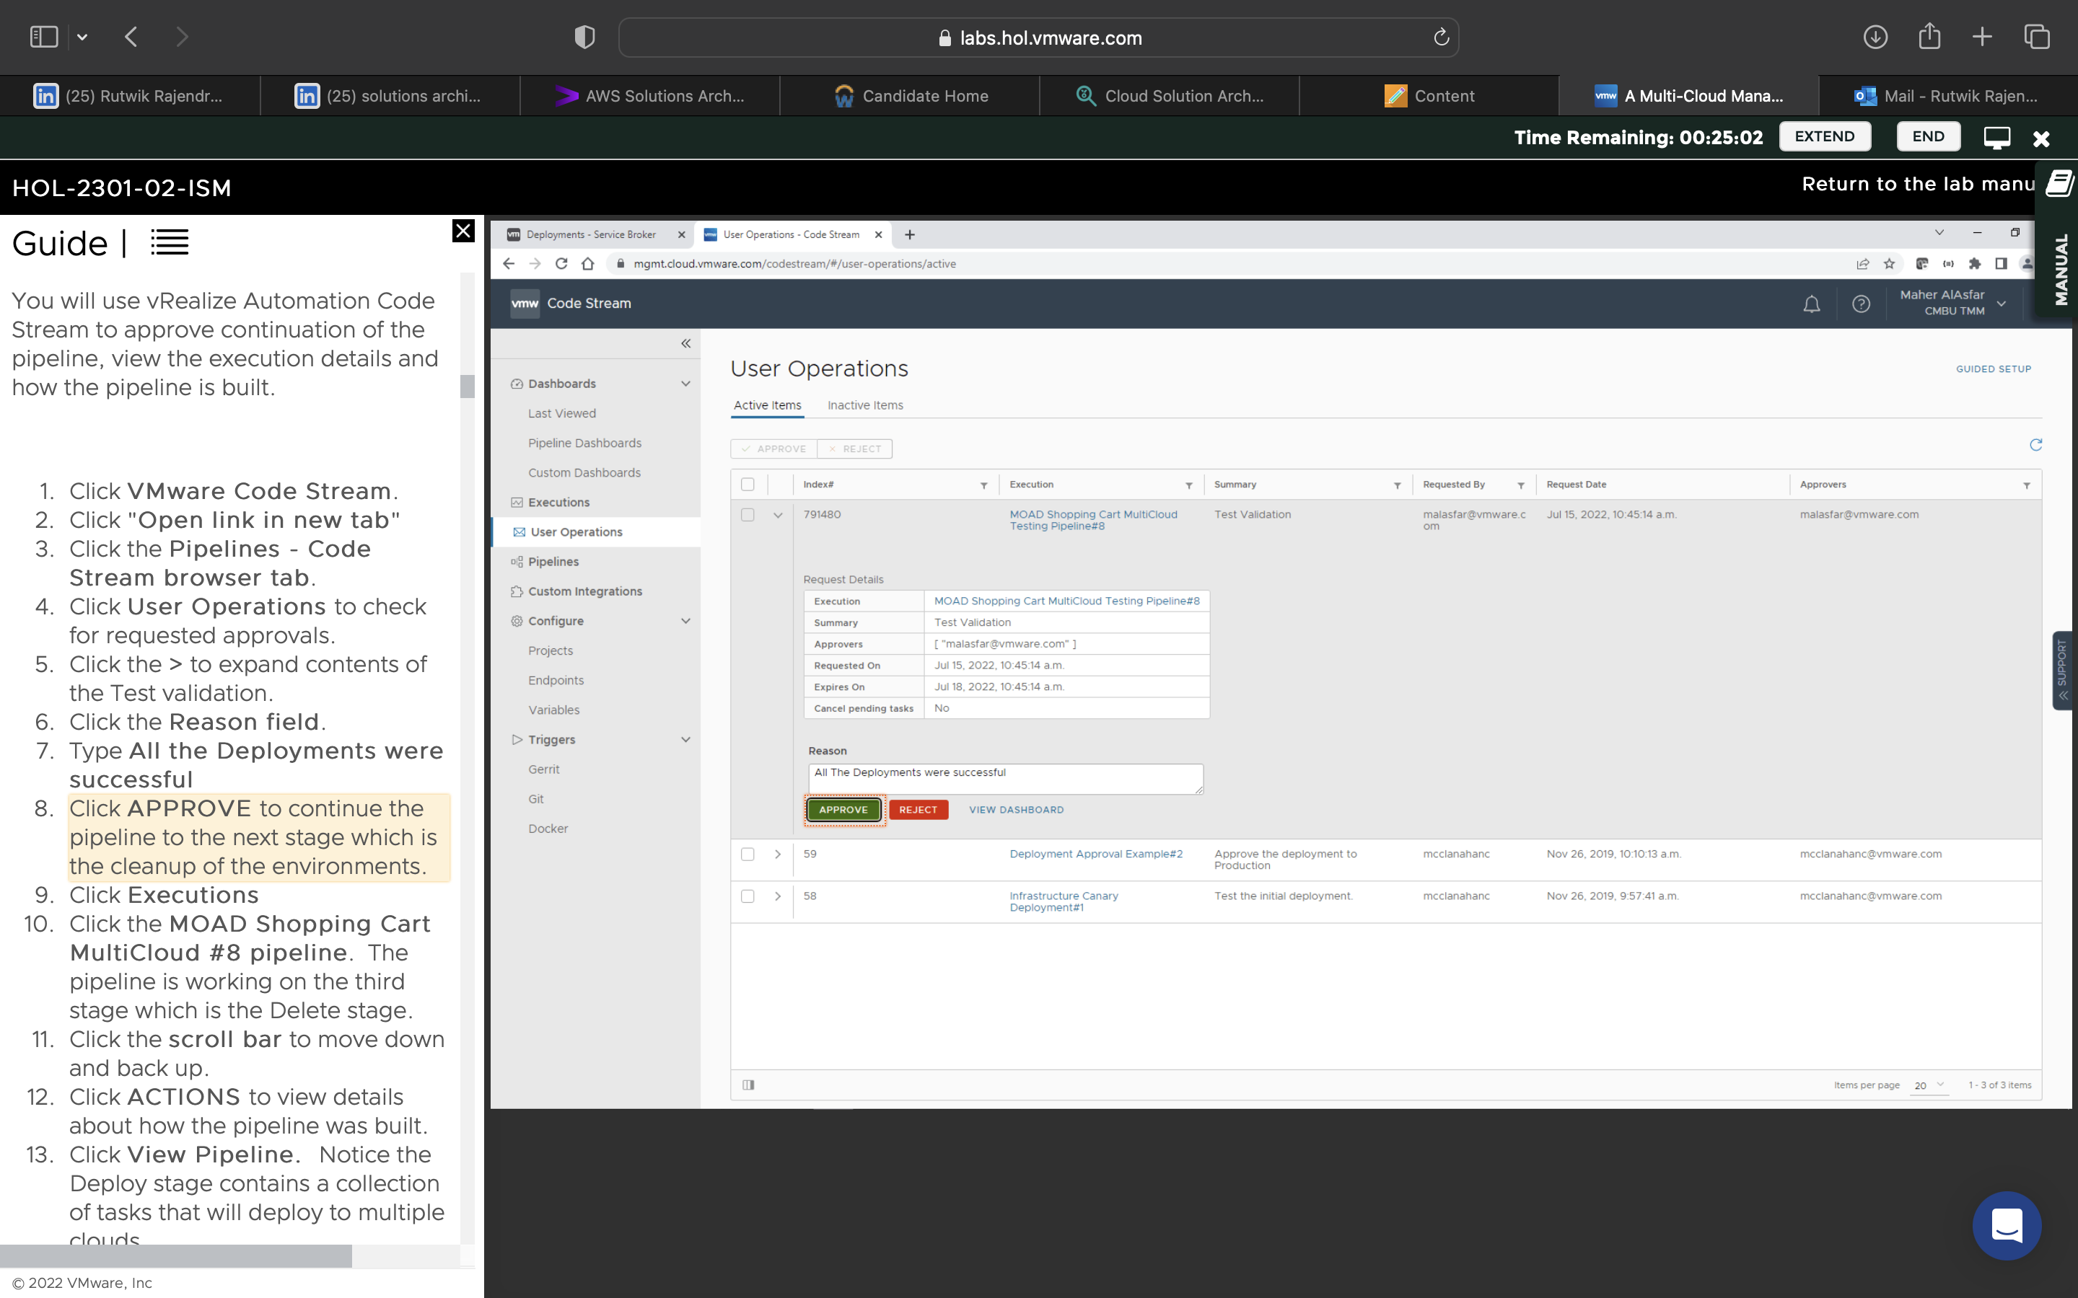

Approved the continuation of all pipelines

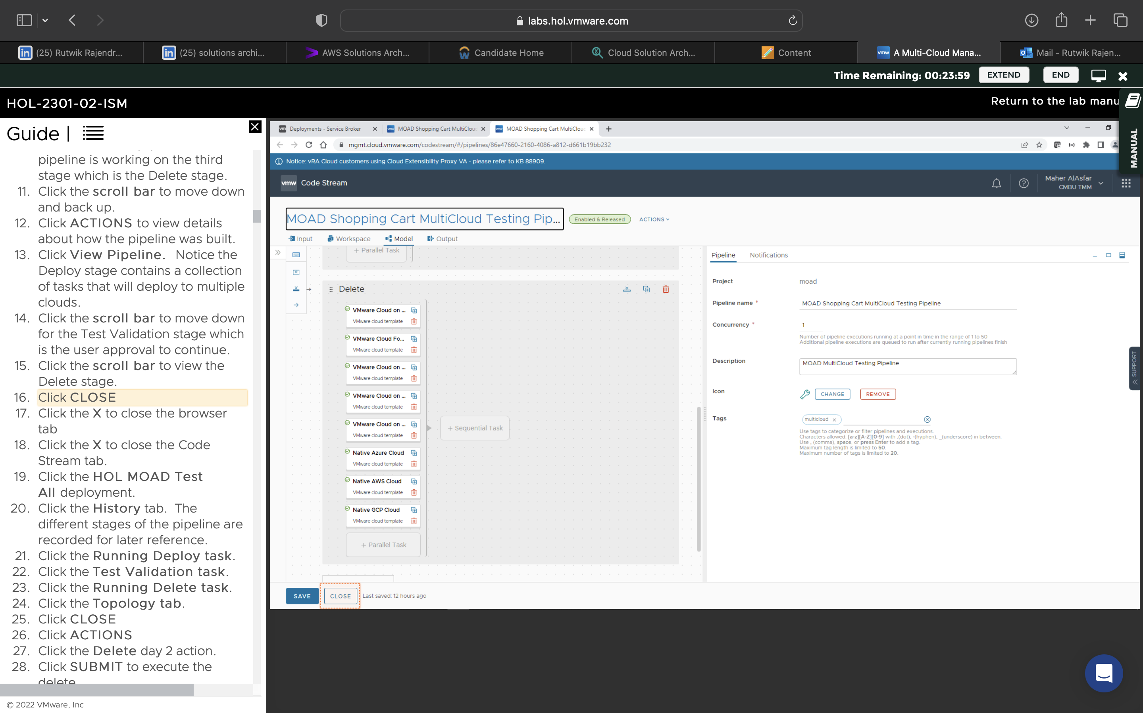

Viewed the pipeline, continued to delete the deployment

Automation of Cloud Admin:

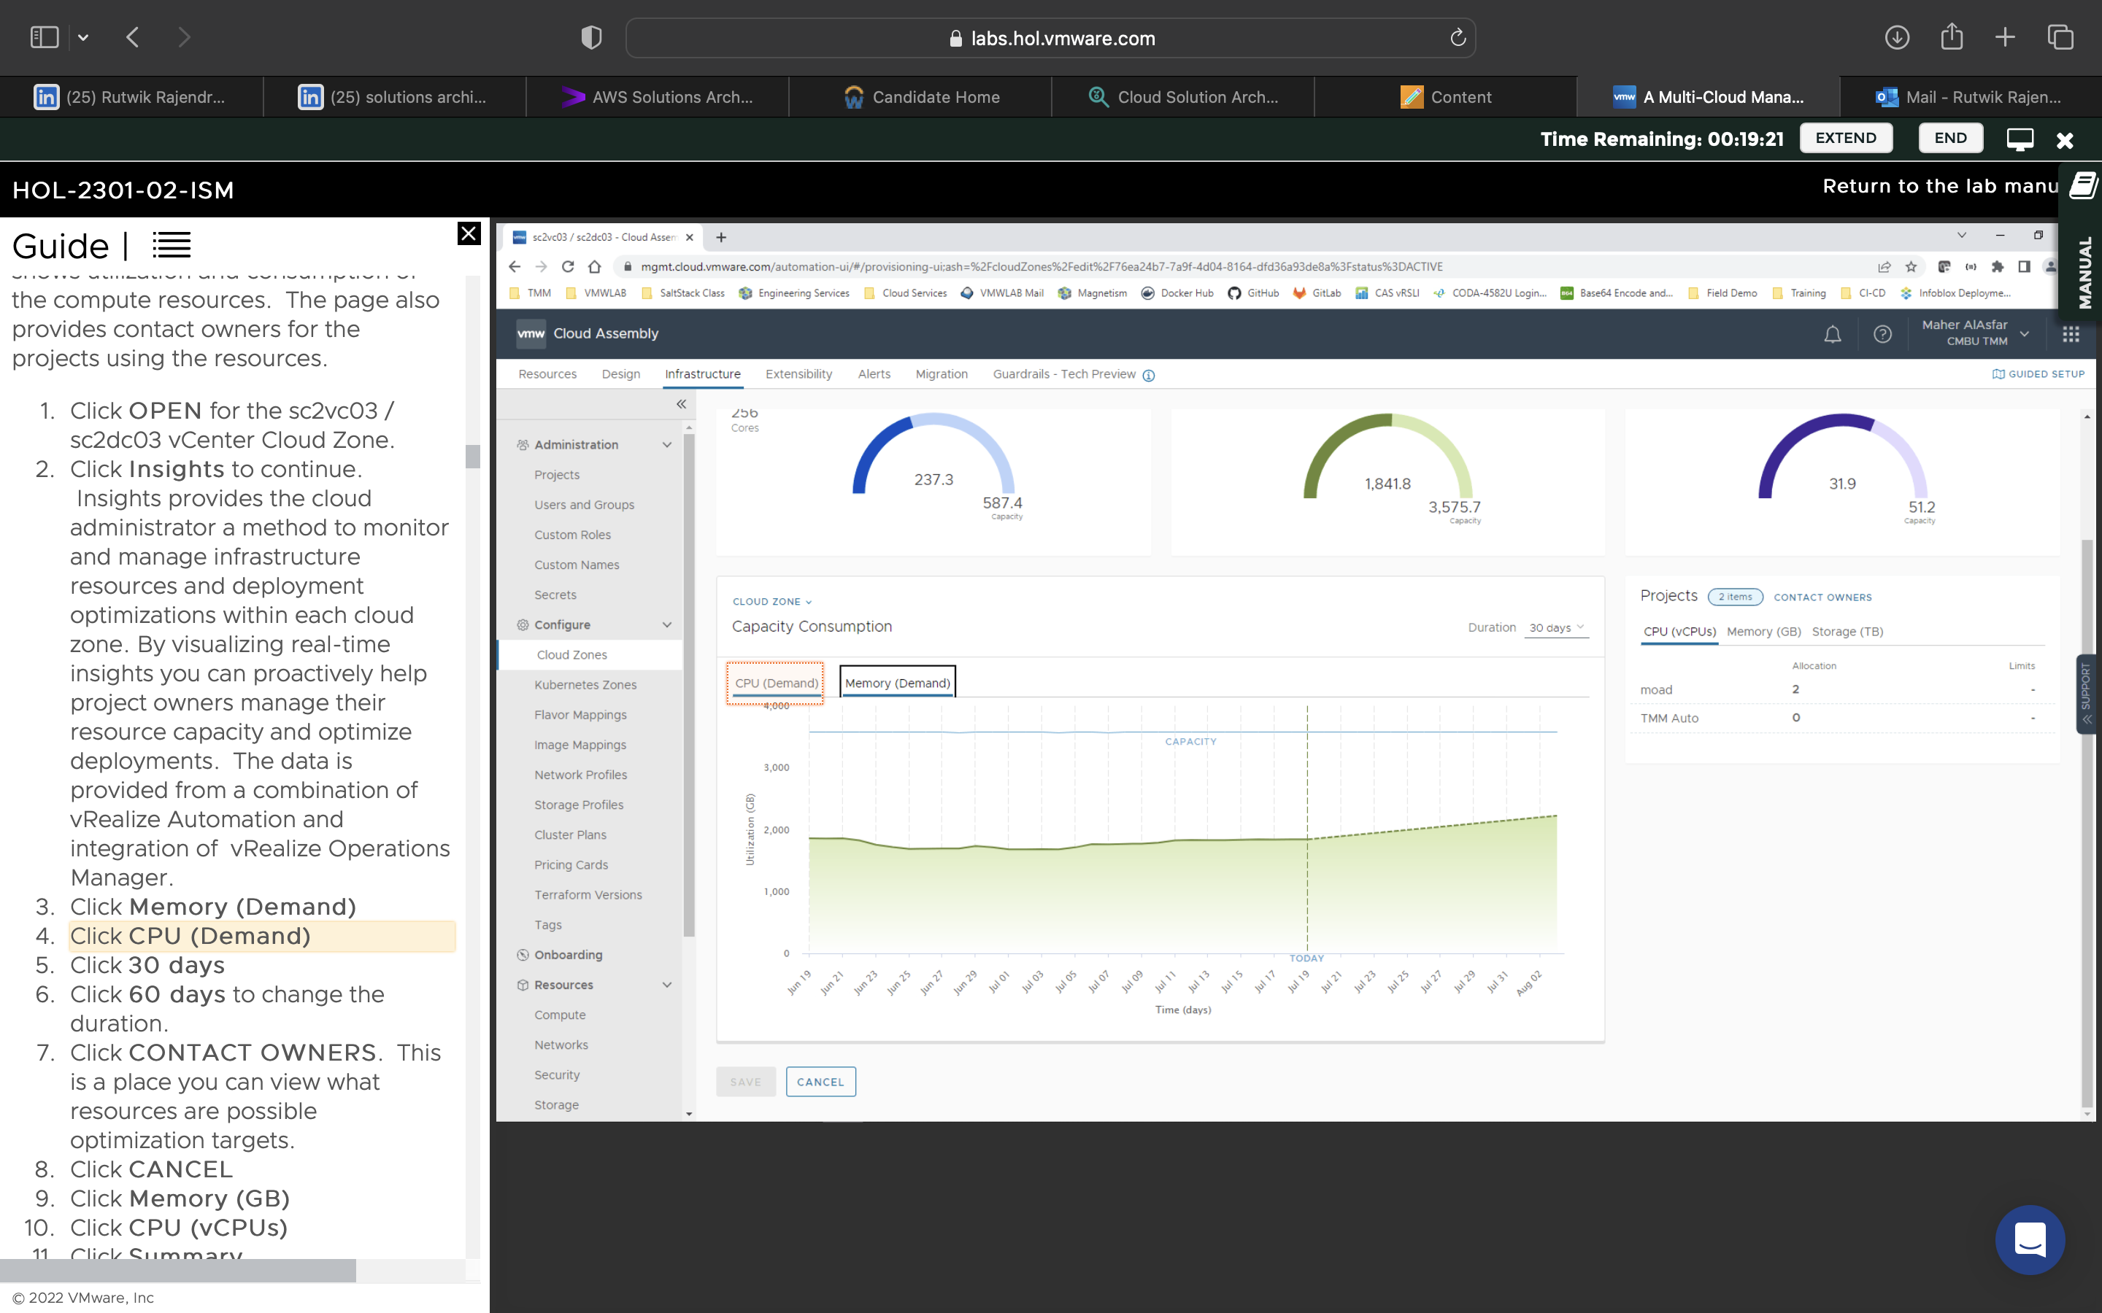

Setting up the cloud for governed consumption by reviewing vCenter endpoints for multiple SaaS accounts.

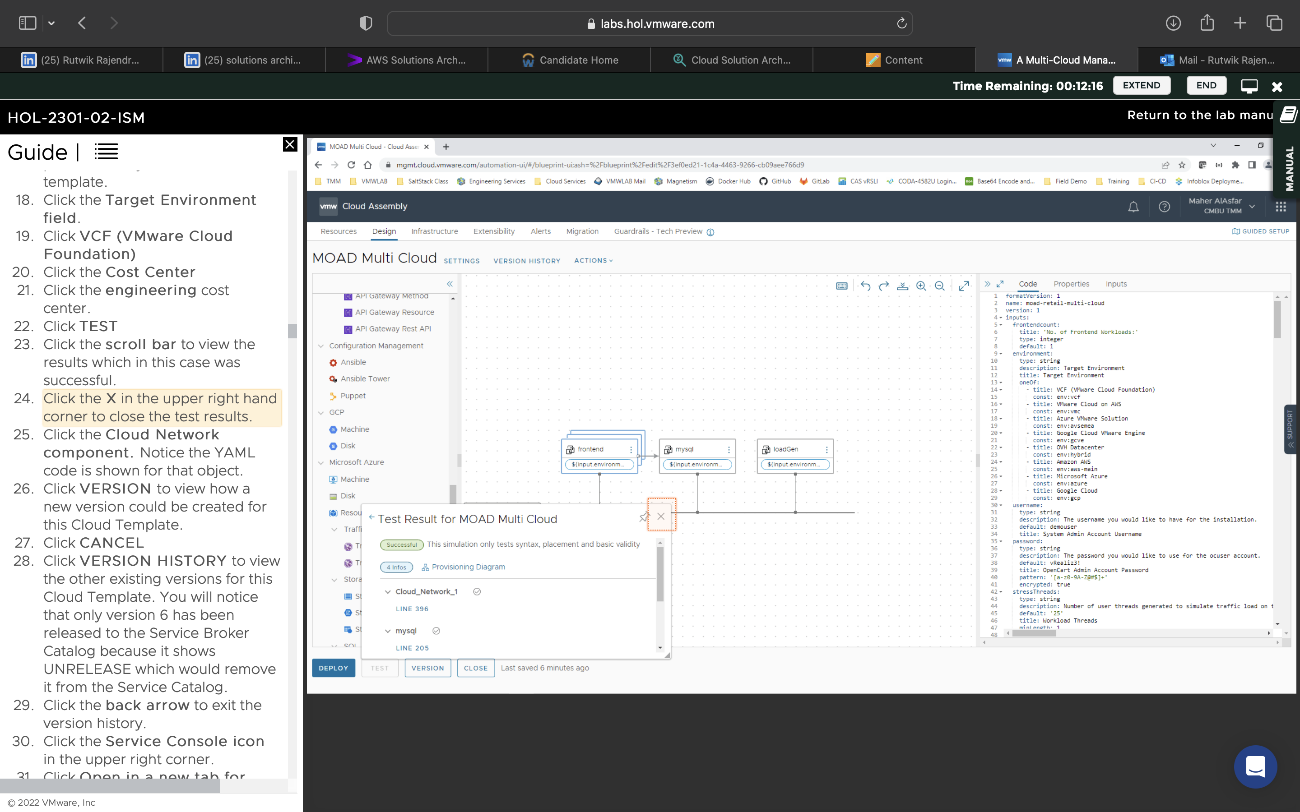

Testing the environment for the YAML code validity to calculate costs for this environment

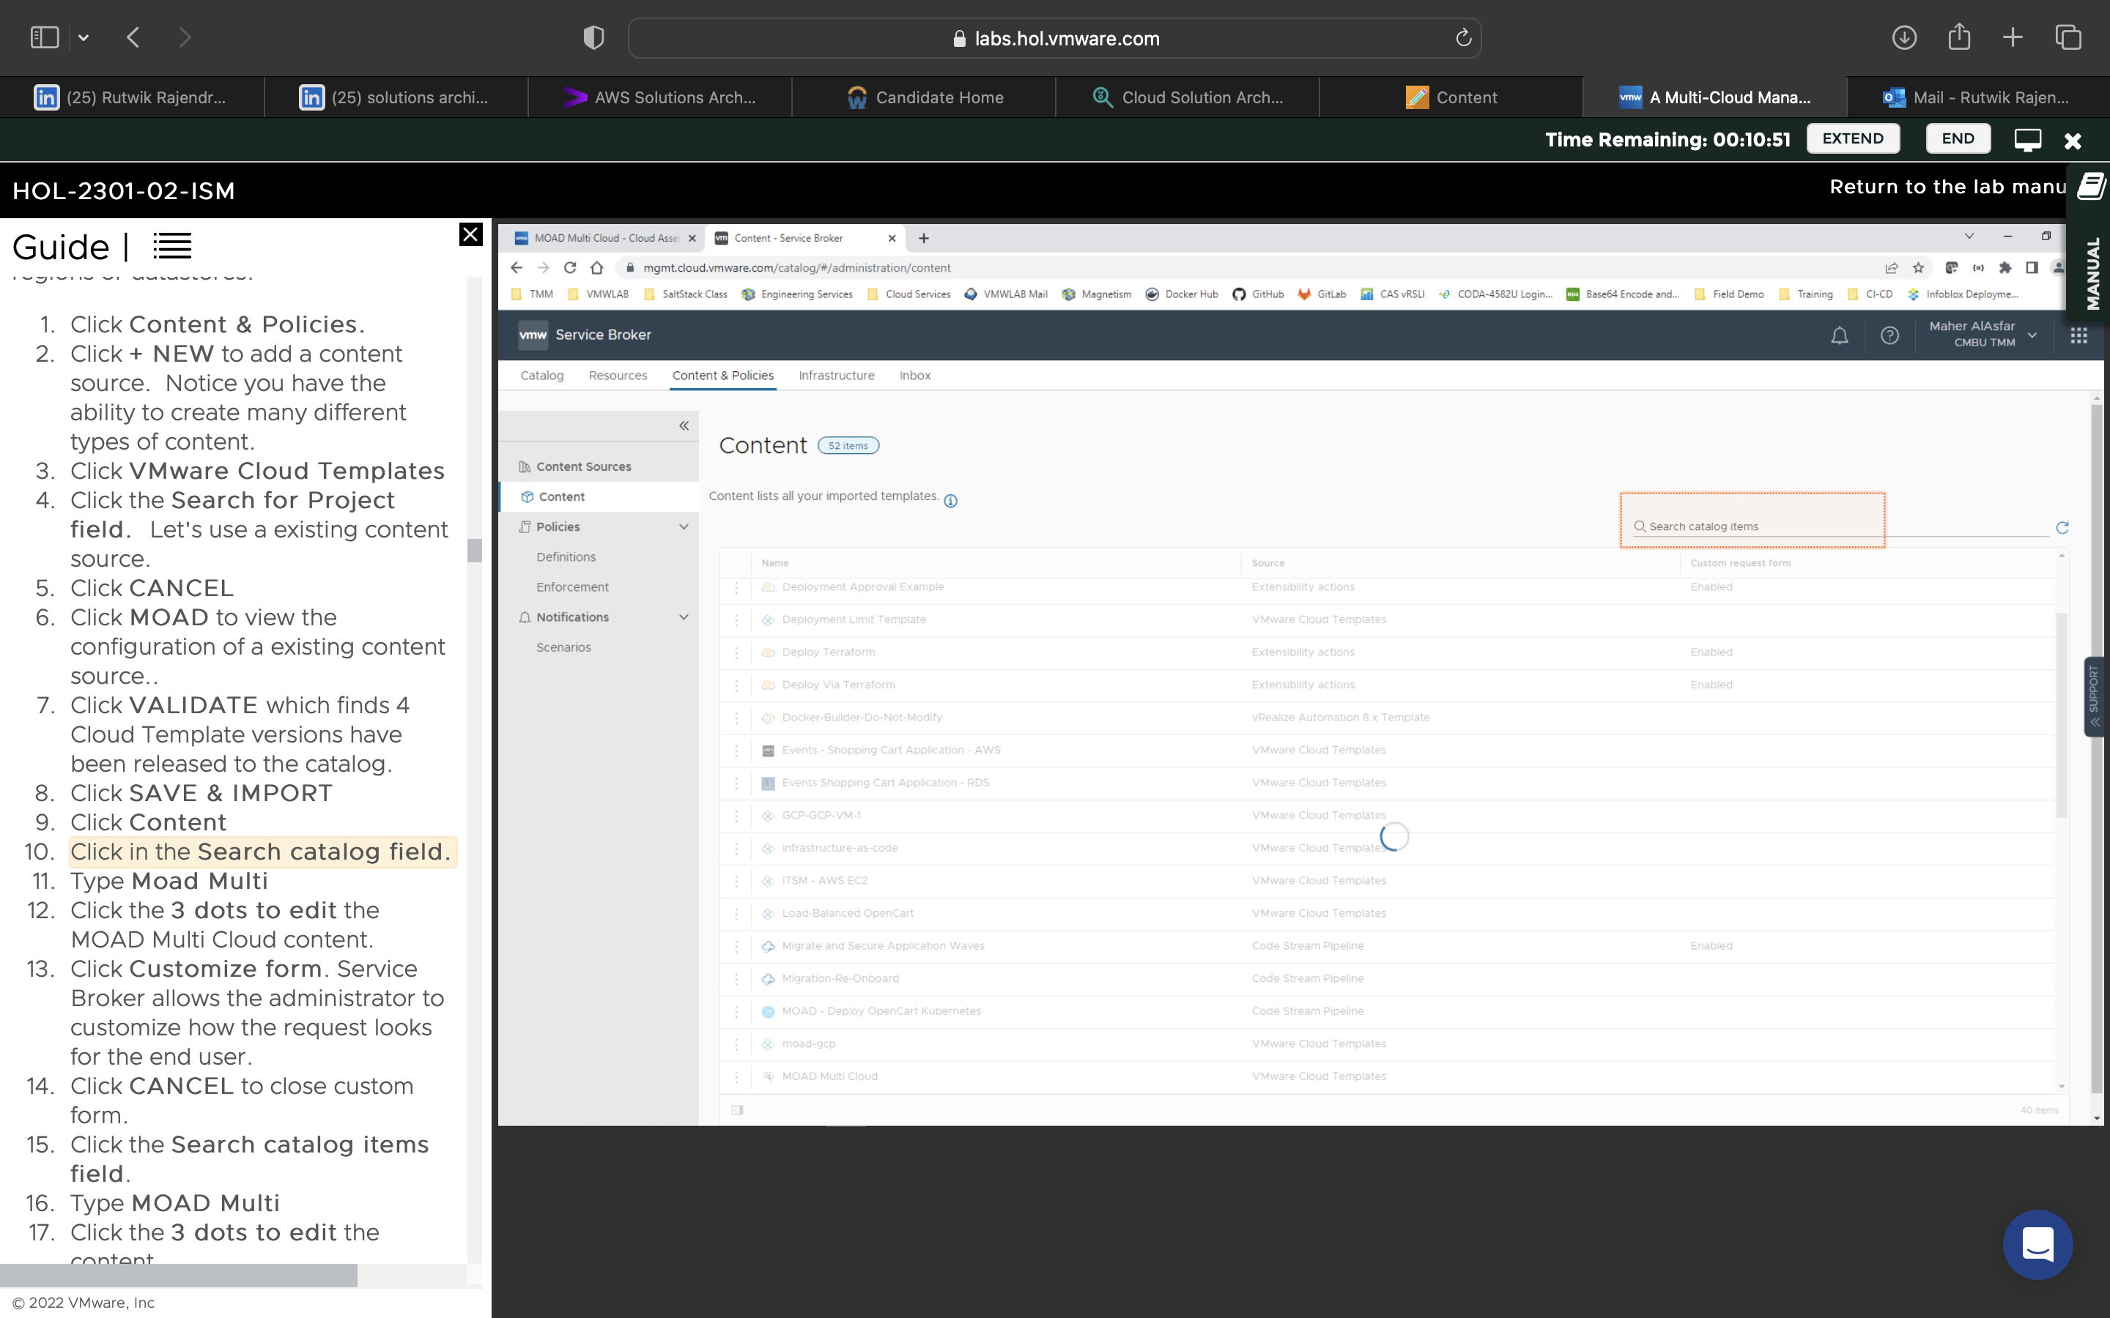

Validated the MOAD configuration in a new service broker tab, and saved and imported it.

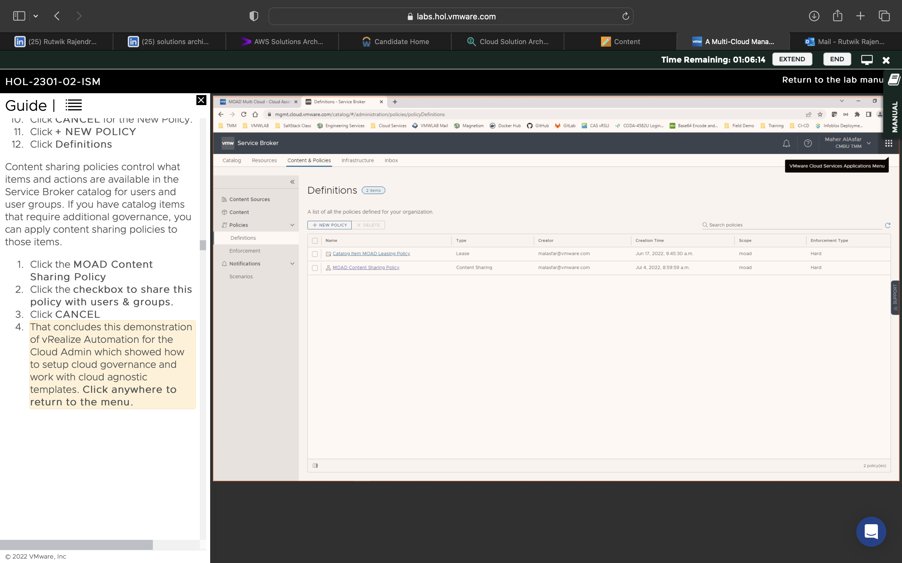

Tried to create new definitions for policies, and experimented with group sharing policies

Enforcing Cloud Gaurdrails:

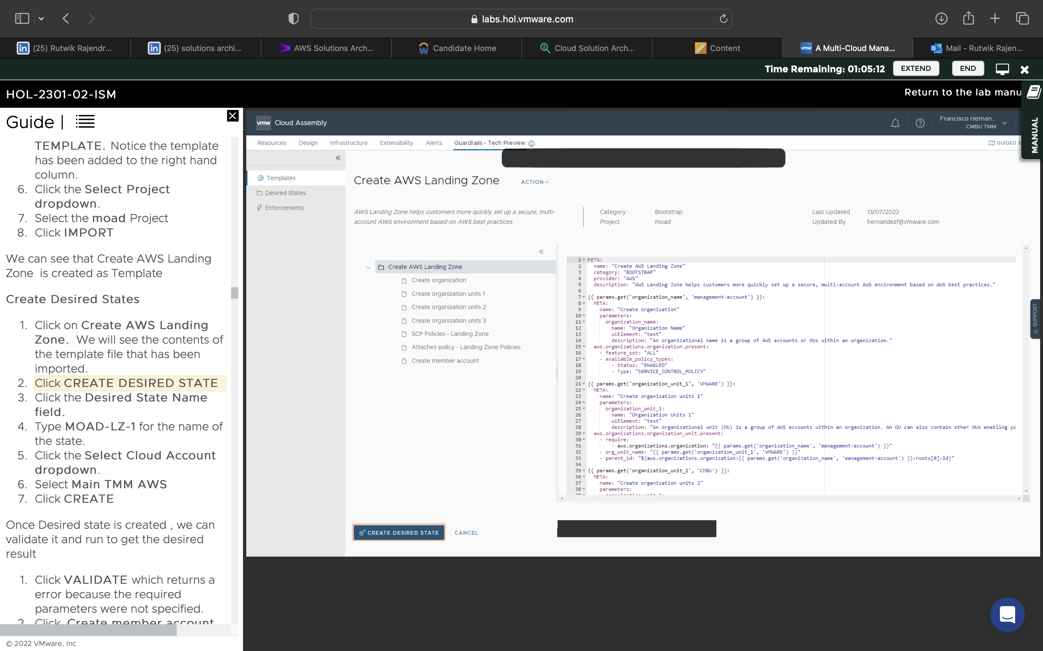

Created AWS landing zone, checked if all parameters were correct, validated it and ran the environment

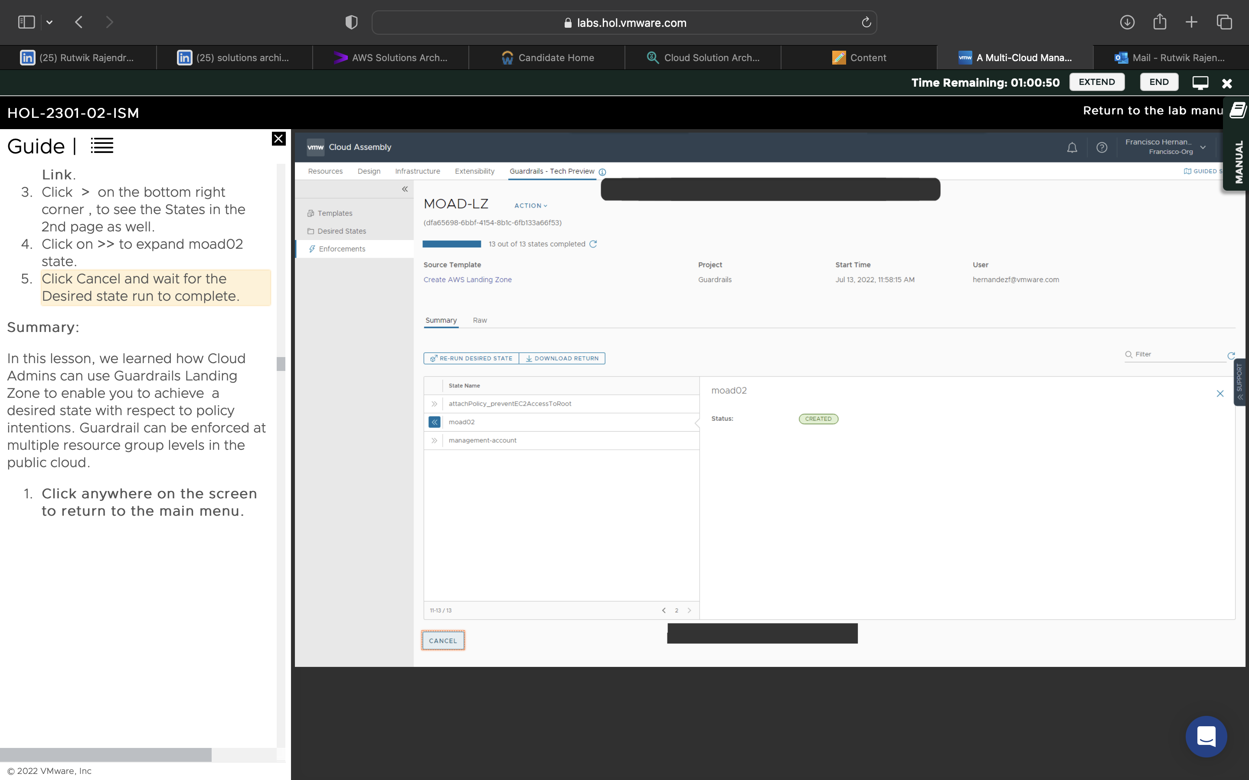

Checked a list of environments and checked the state of MOAD

Performance for Cloud Consumer:

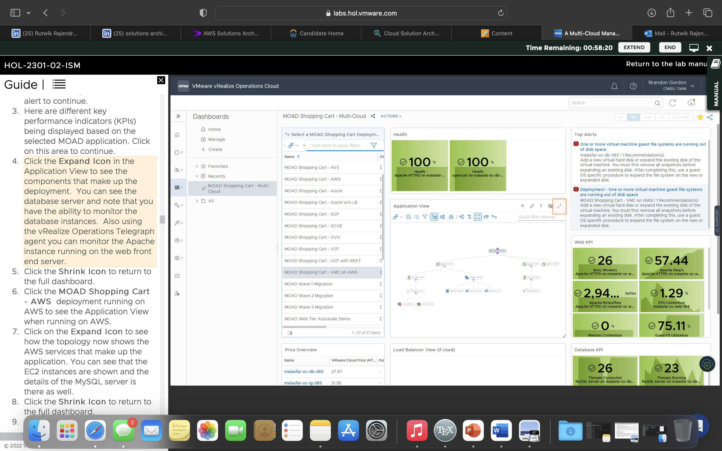

Viewed on vRealise the different warnings based on KPIs, viewed relationships and rules of the applications of the shopping cart

Performance for Cloud Admin:

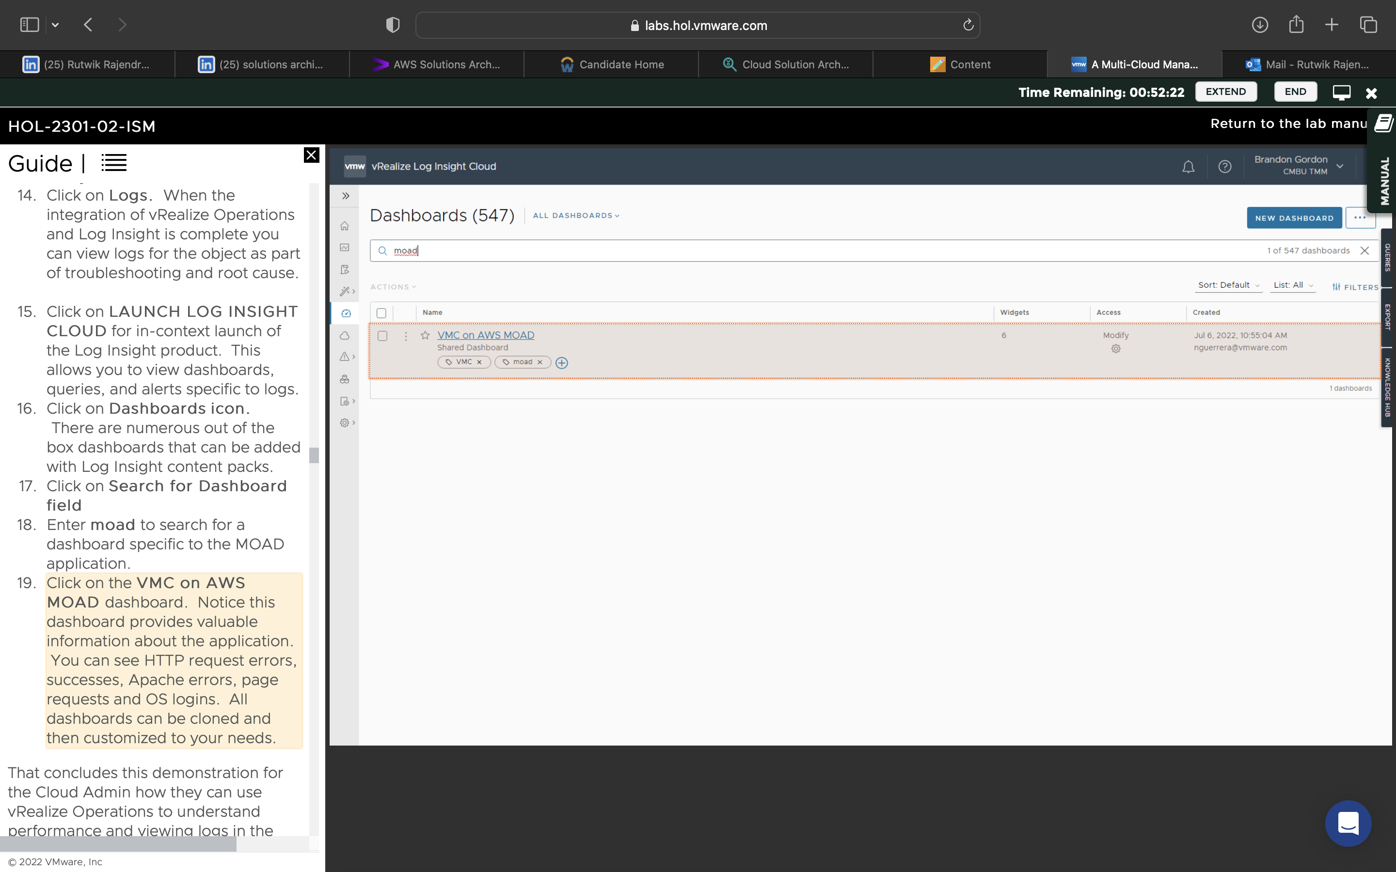

Viewed the relationship diagram for the shopping cart, viewed alerts, KPIs, did some troubleshooting, viewed log insights and the MOAD dashboard that gives an overview of the thing.

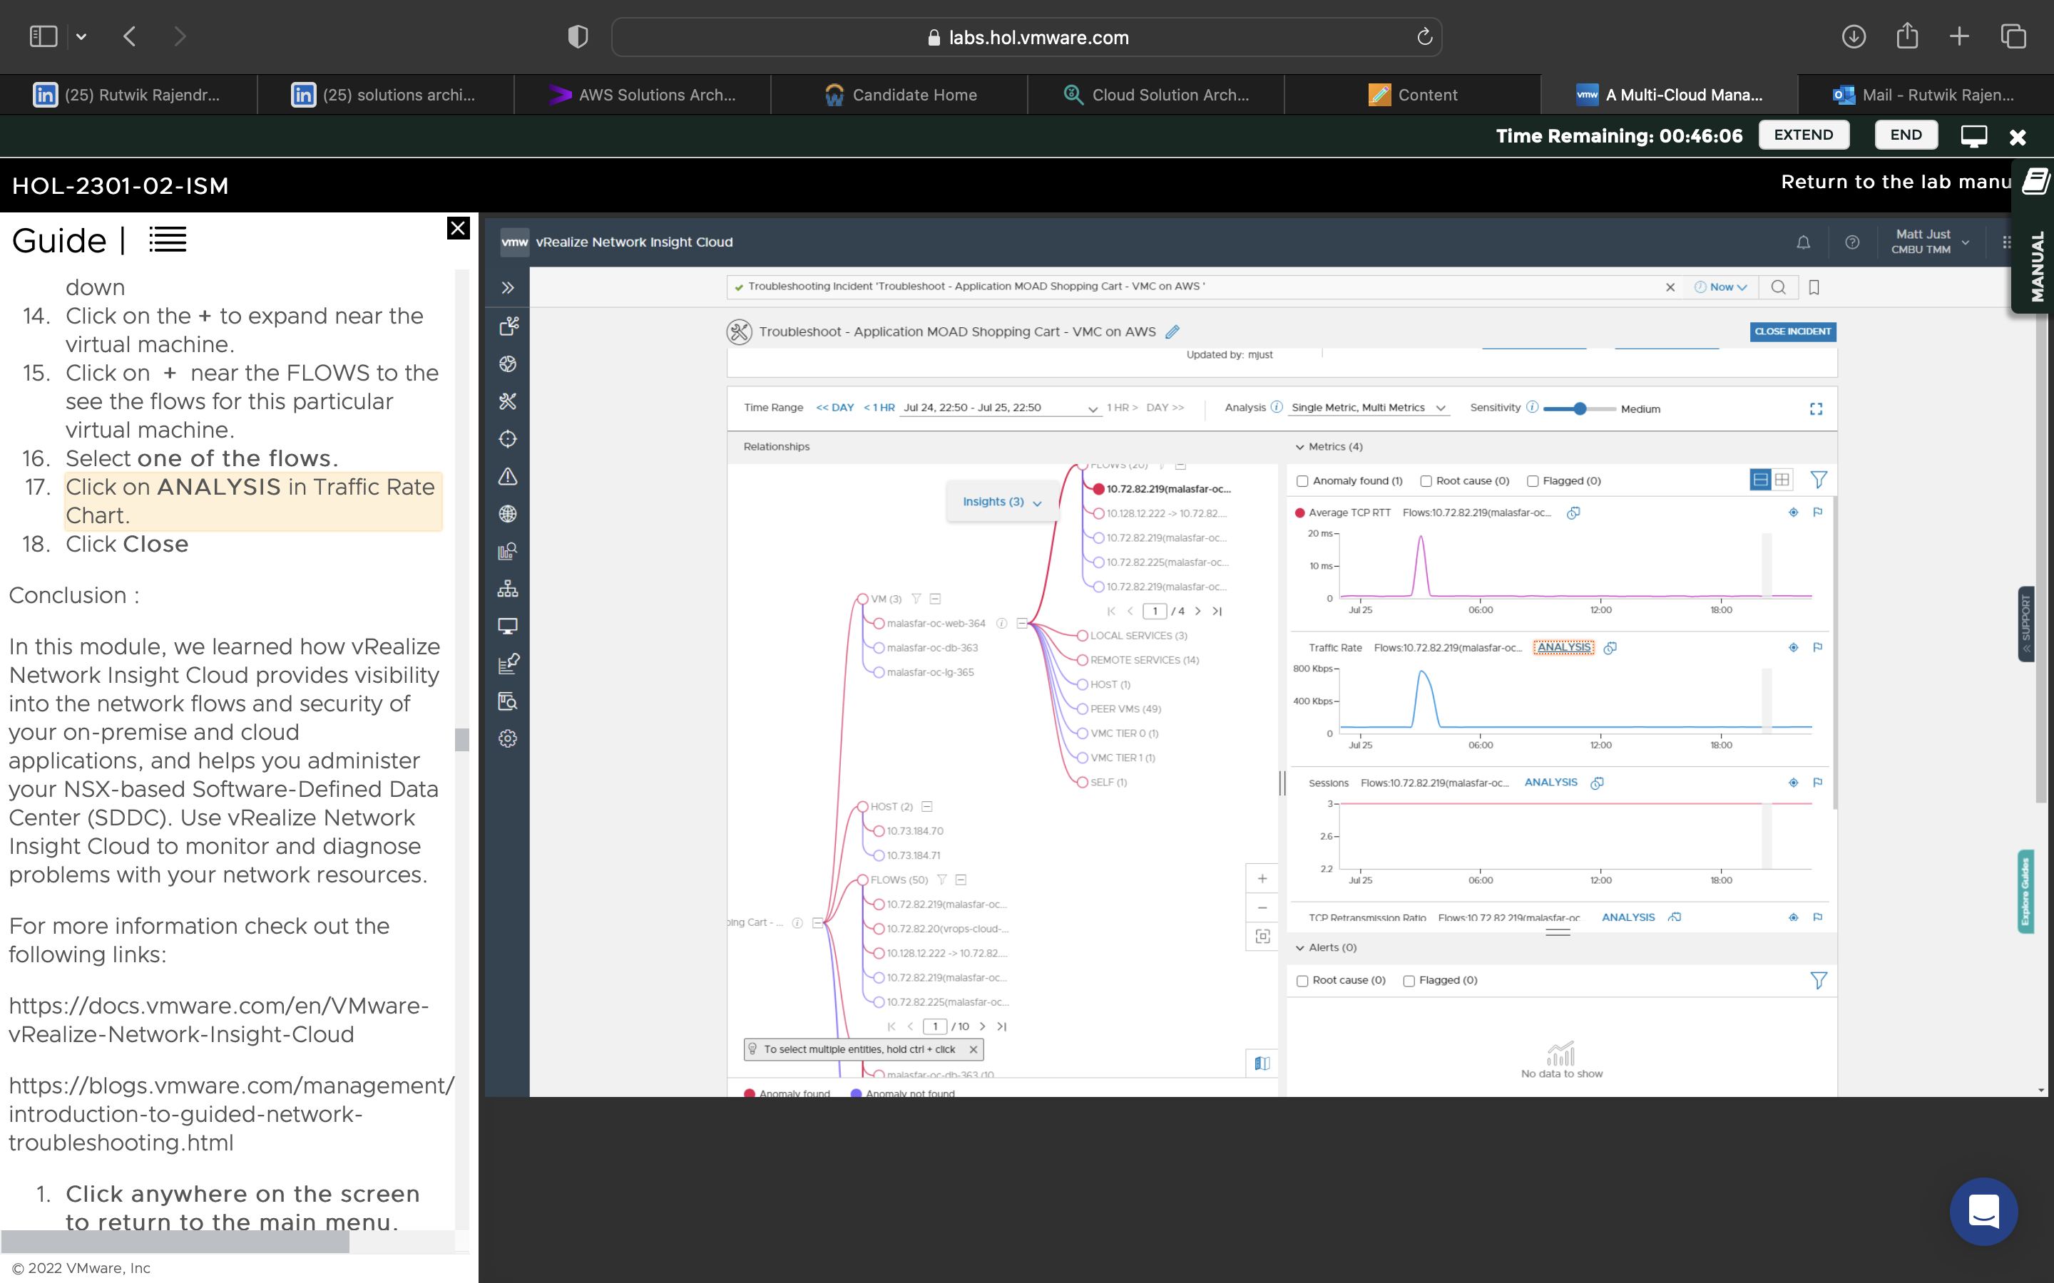

Ran a troubleshooting session with the flow diagrams and viewing path topologies and flow insights to view alerts and errors in the system.

Cost for Cloud Consumer:

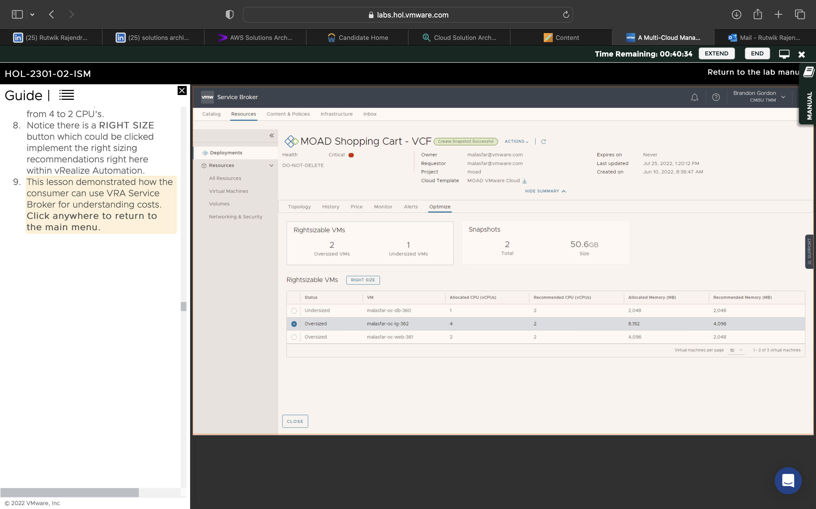

Learnt how the user can view the pricing for any product on a daily, weekly, or monthly basis.

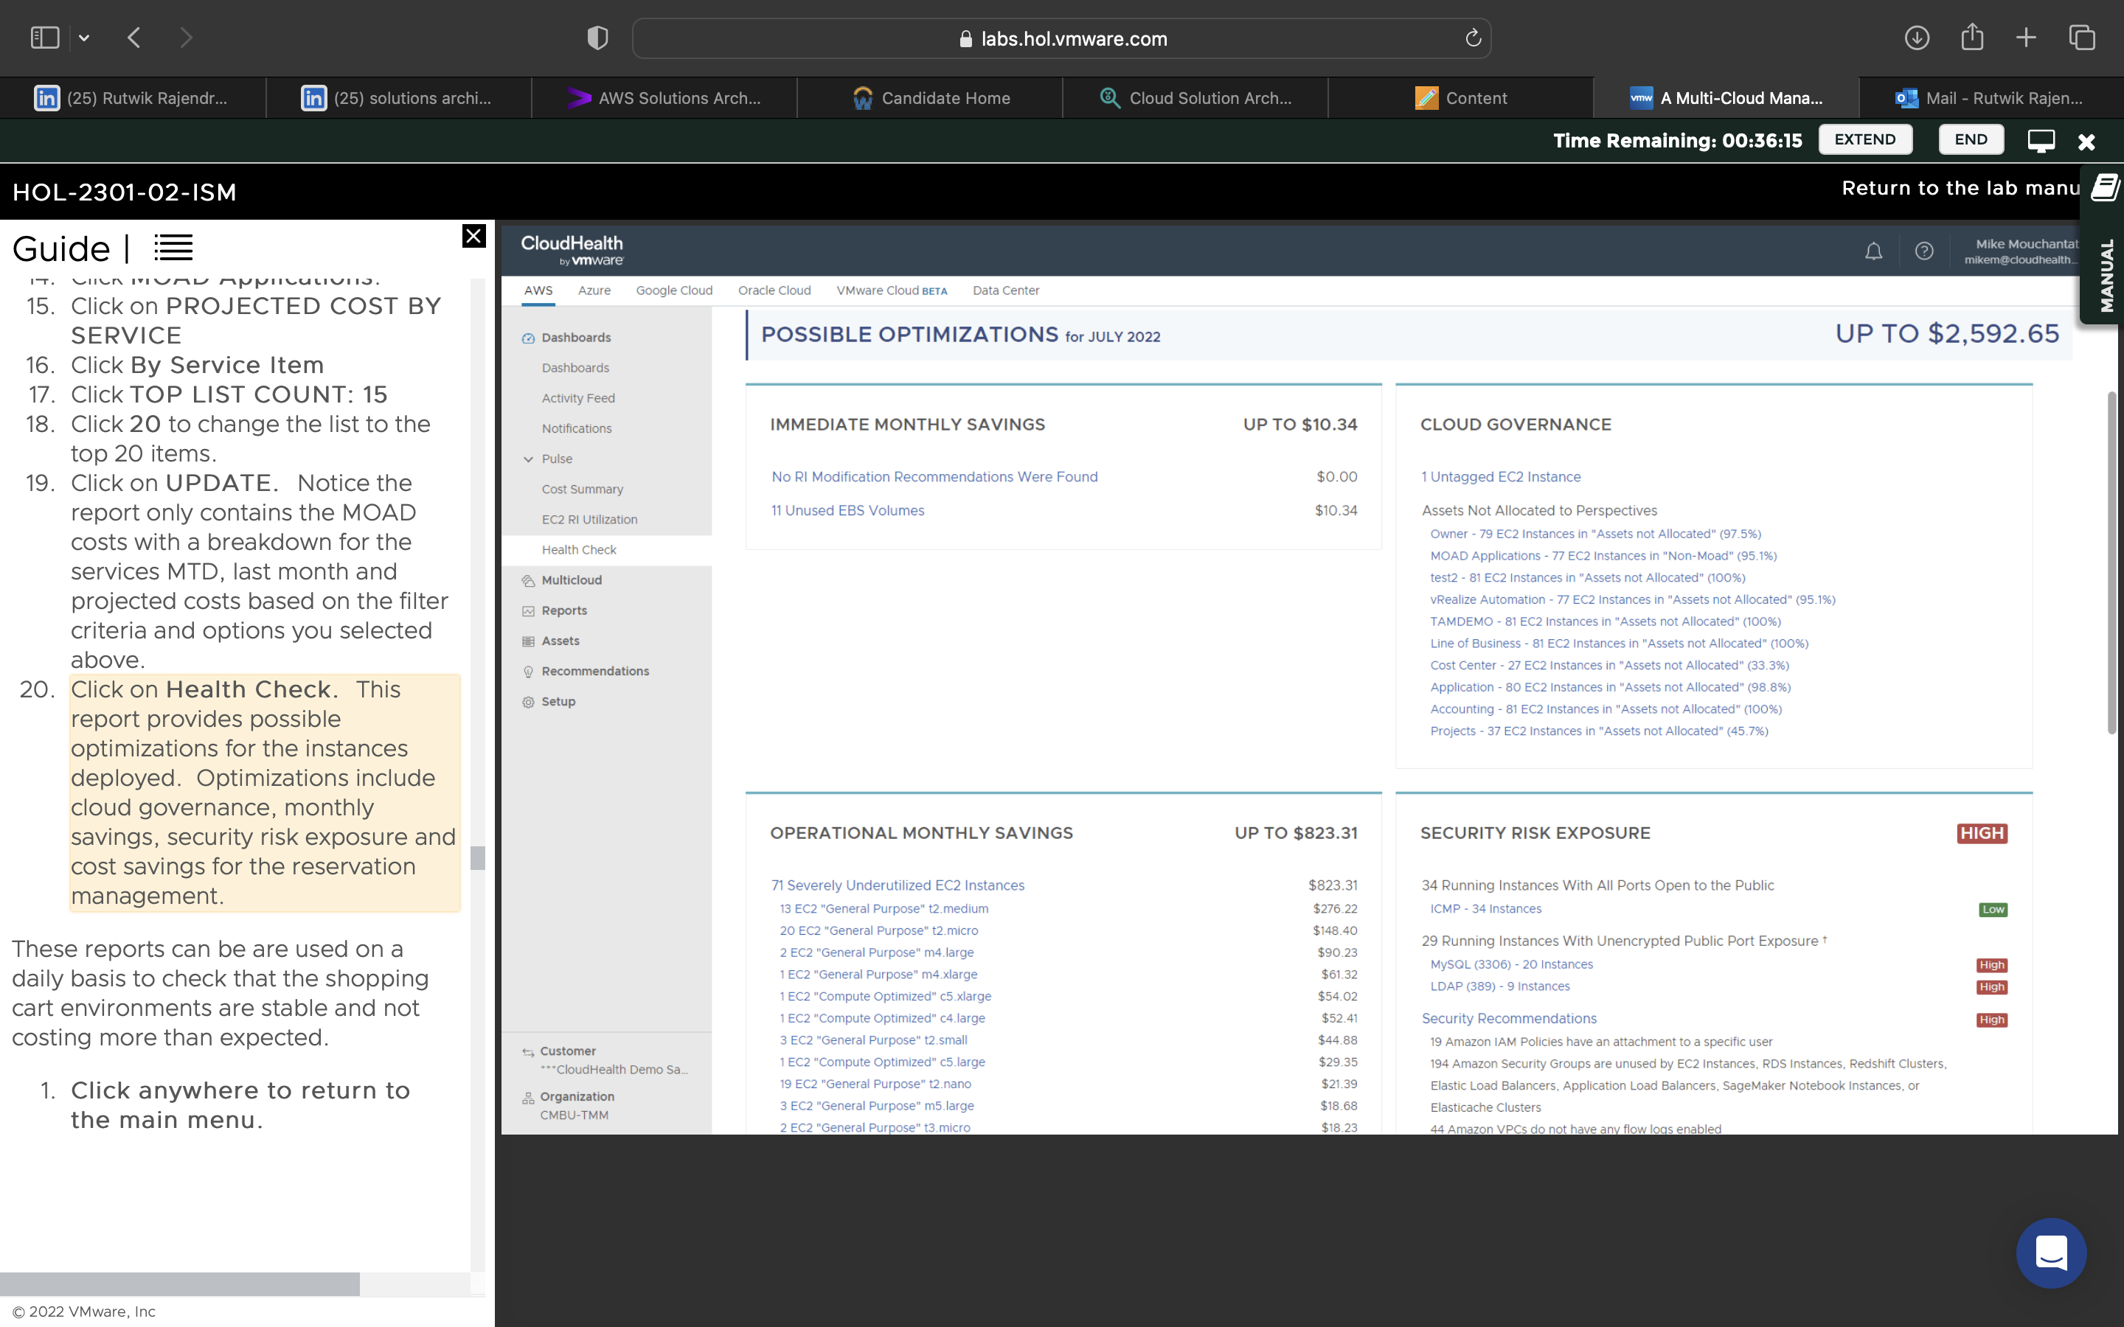

Learnt how the customer can view a dashboard to see the pricing, with various graphs of cost breakdown and compare it to the entire history of paying for it, how to apply filters in terms of cost, to view cost of certain specific services/subcategories.

Cost for Cloud Admin:

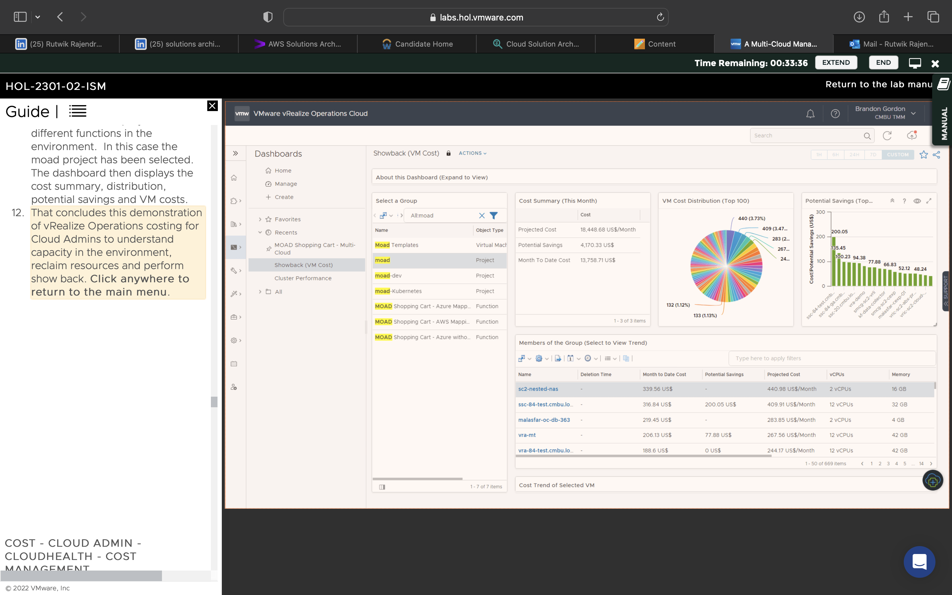

Realized how to view savings, historical trends, cost overviews for products, etc, from an admin perspective to optimize recommendations.

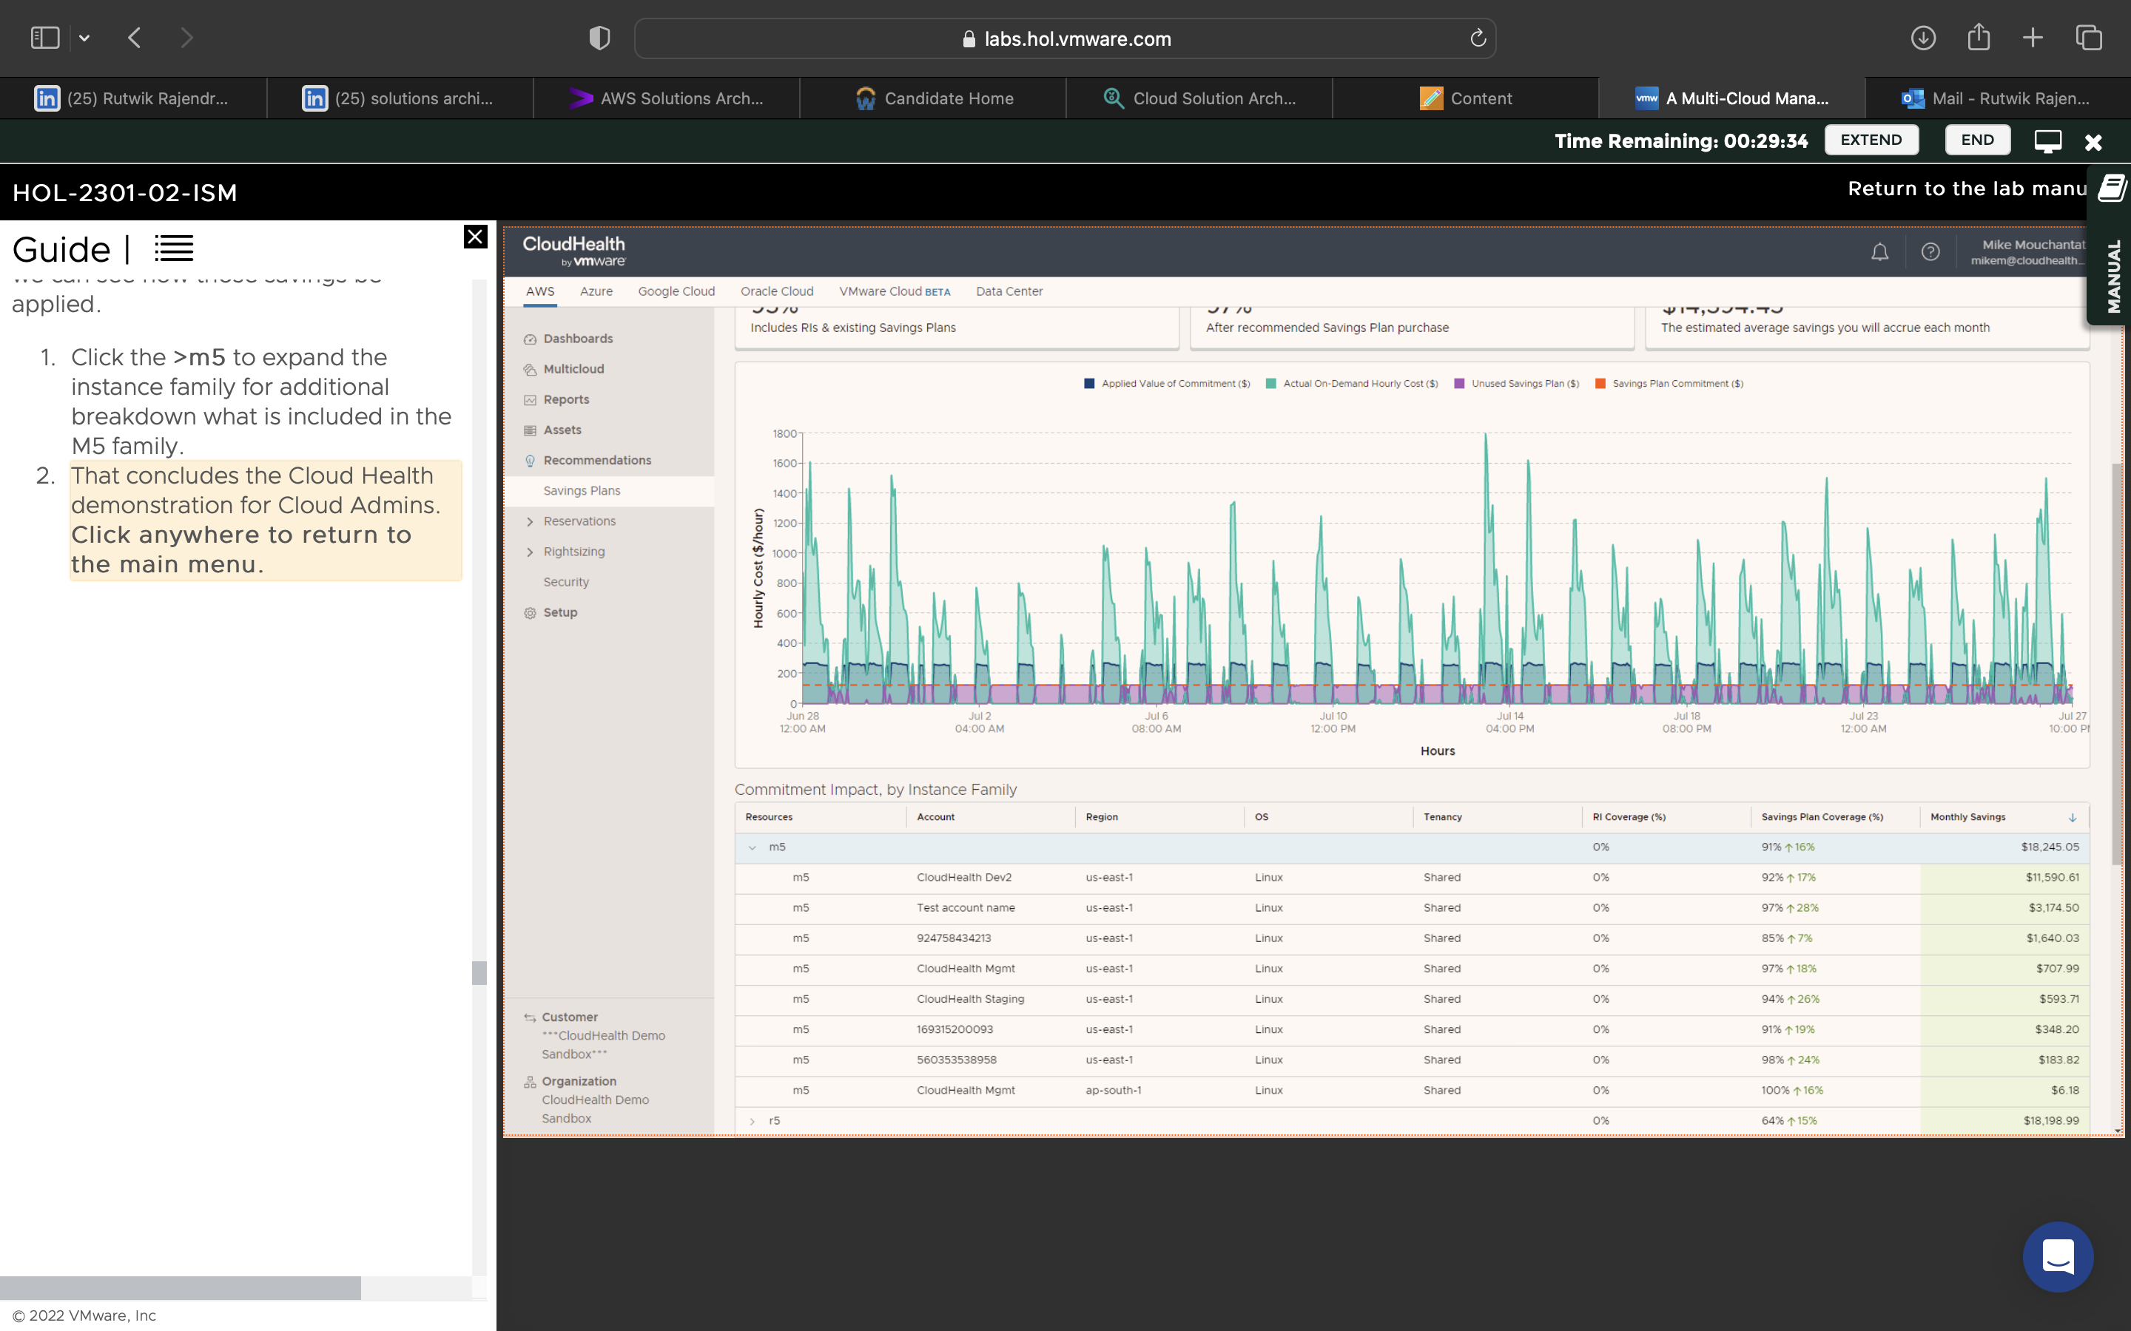

Learnt how to maximize savings, view the impact on the physical servers, how to distribute loads and get recommendations for bettering performance.

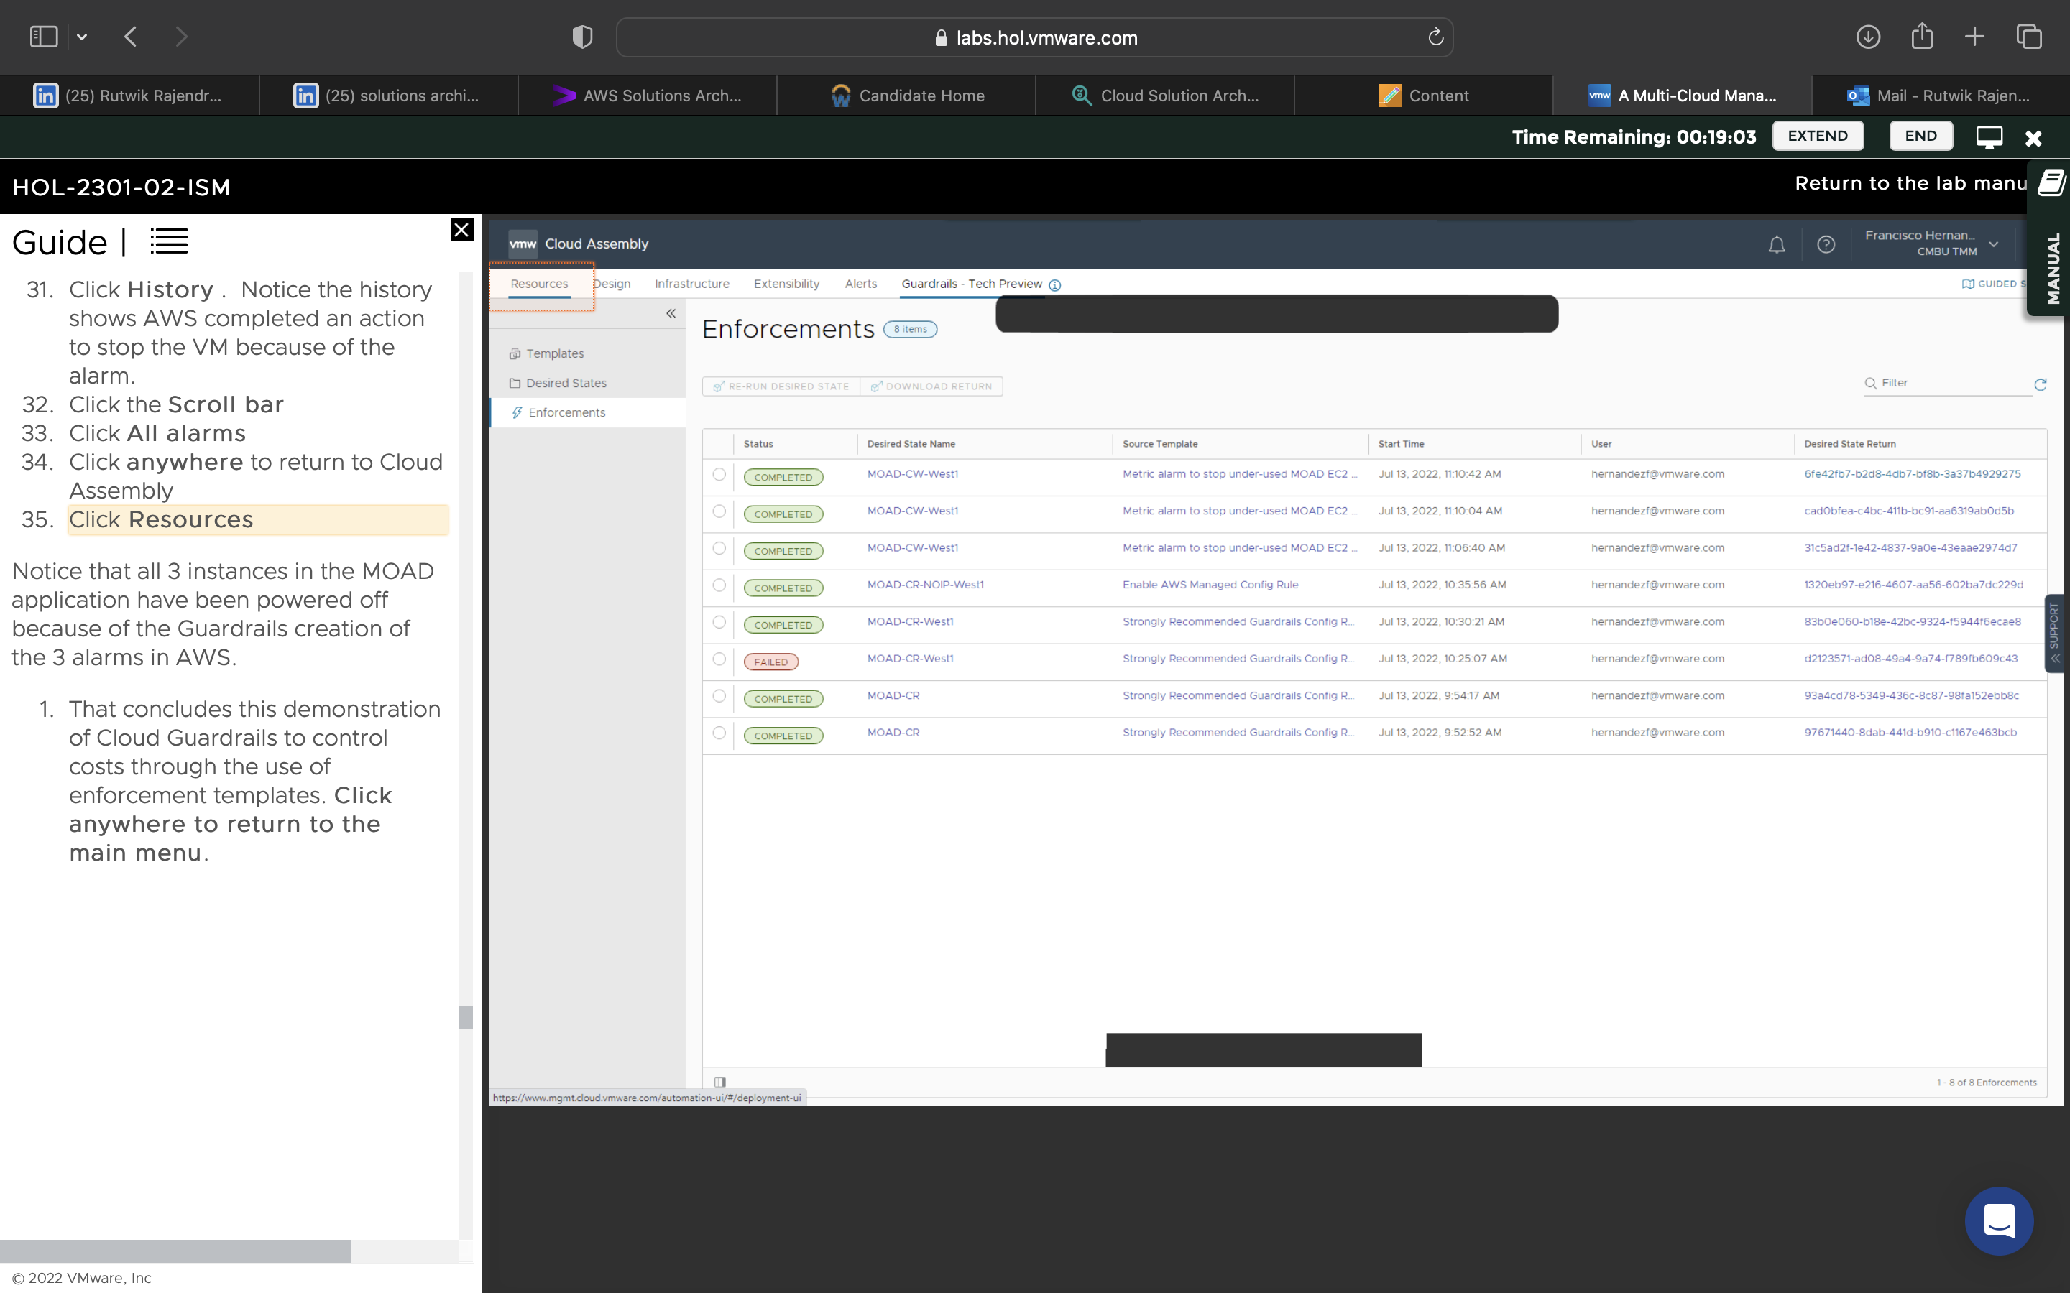

Learnt how to setup guardrails to switch to VMs with desired states.

Secure Config for Cloud Consumer:

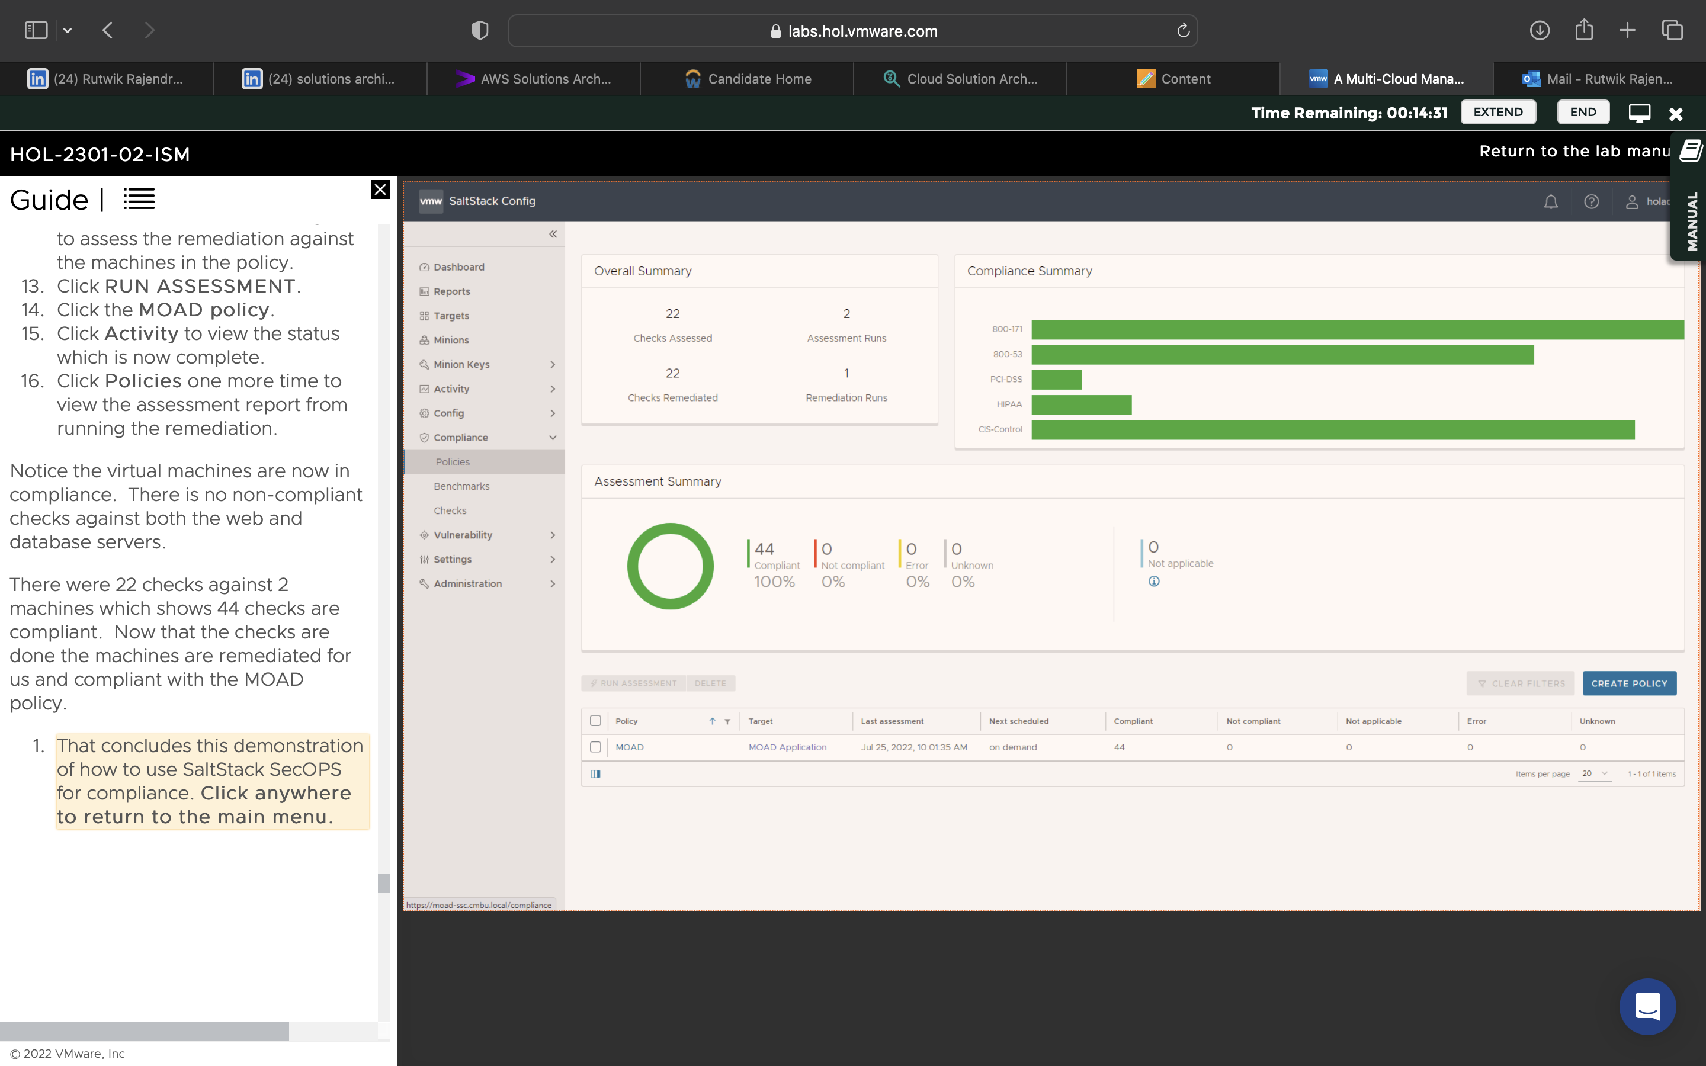

Used SaltStack SecOps to check compliance, edit policies, run assessments for violations, fix errors.

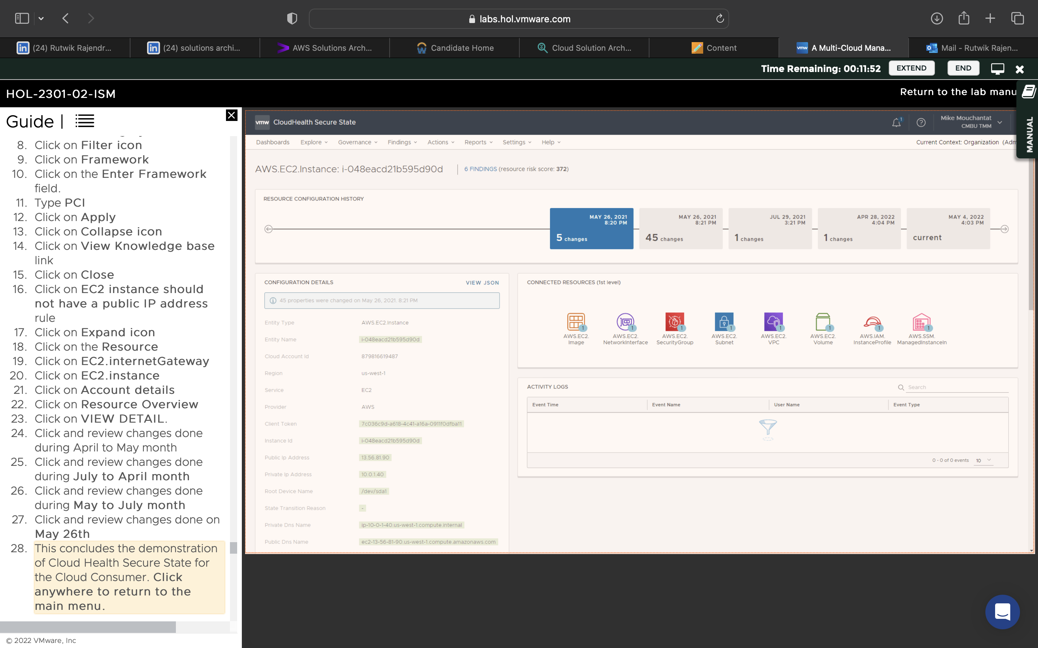

Learnt how make sure the product is not exposed to unnecessary risks.

Secure Config for Cloud admin:

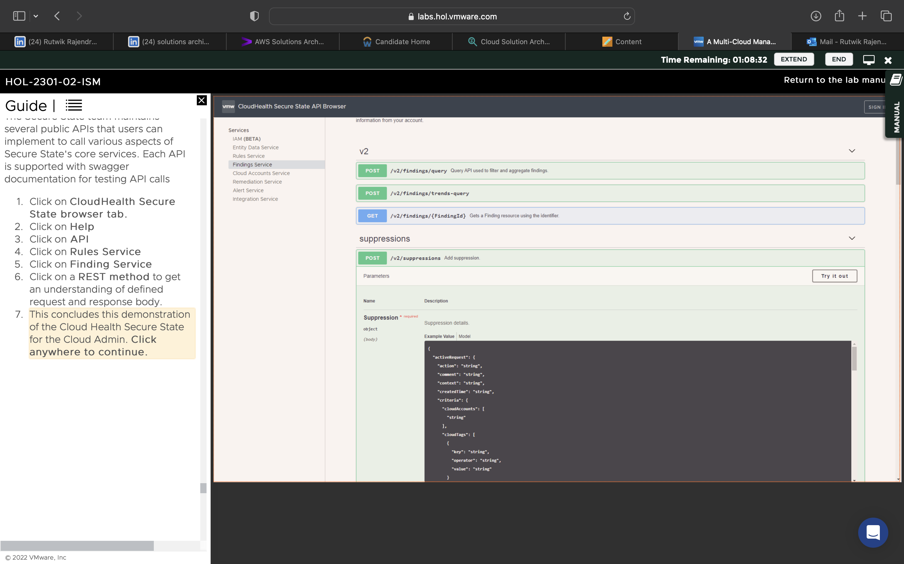

Learnt how to set up remediation which automatically takes care of small violations which are common. Also learnt to invoke Secure State APIs for protection

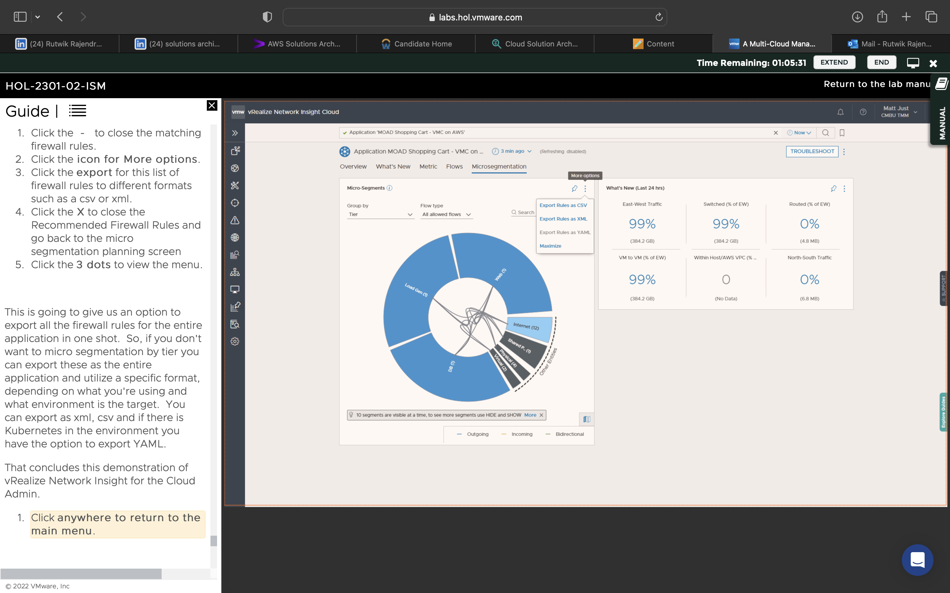

Learnt how to view different segments of insights offered and view the firewalls and make edits to them. We also received recommendations for the firewall rules.

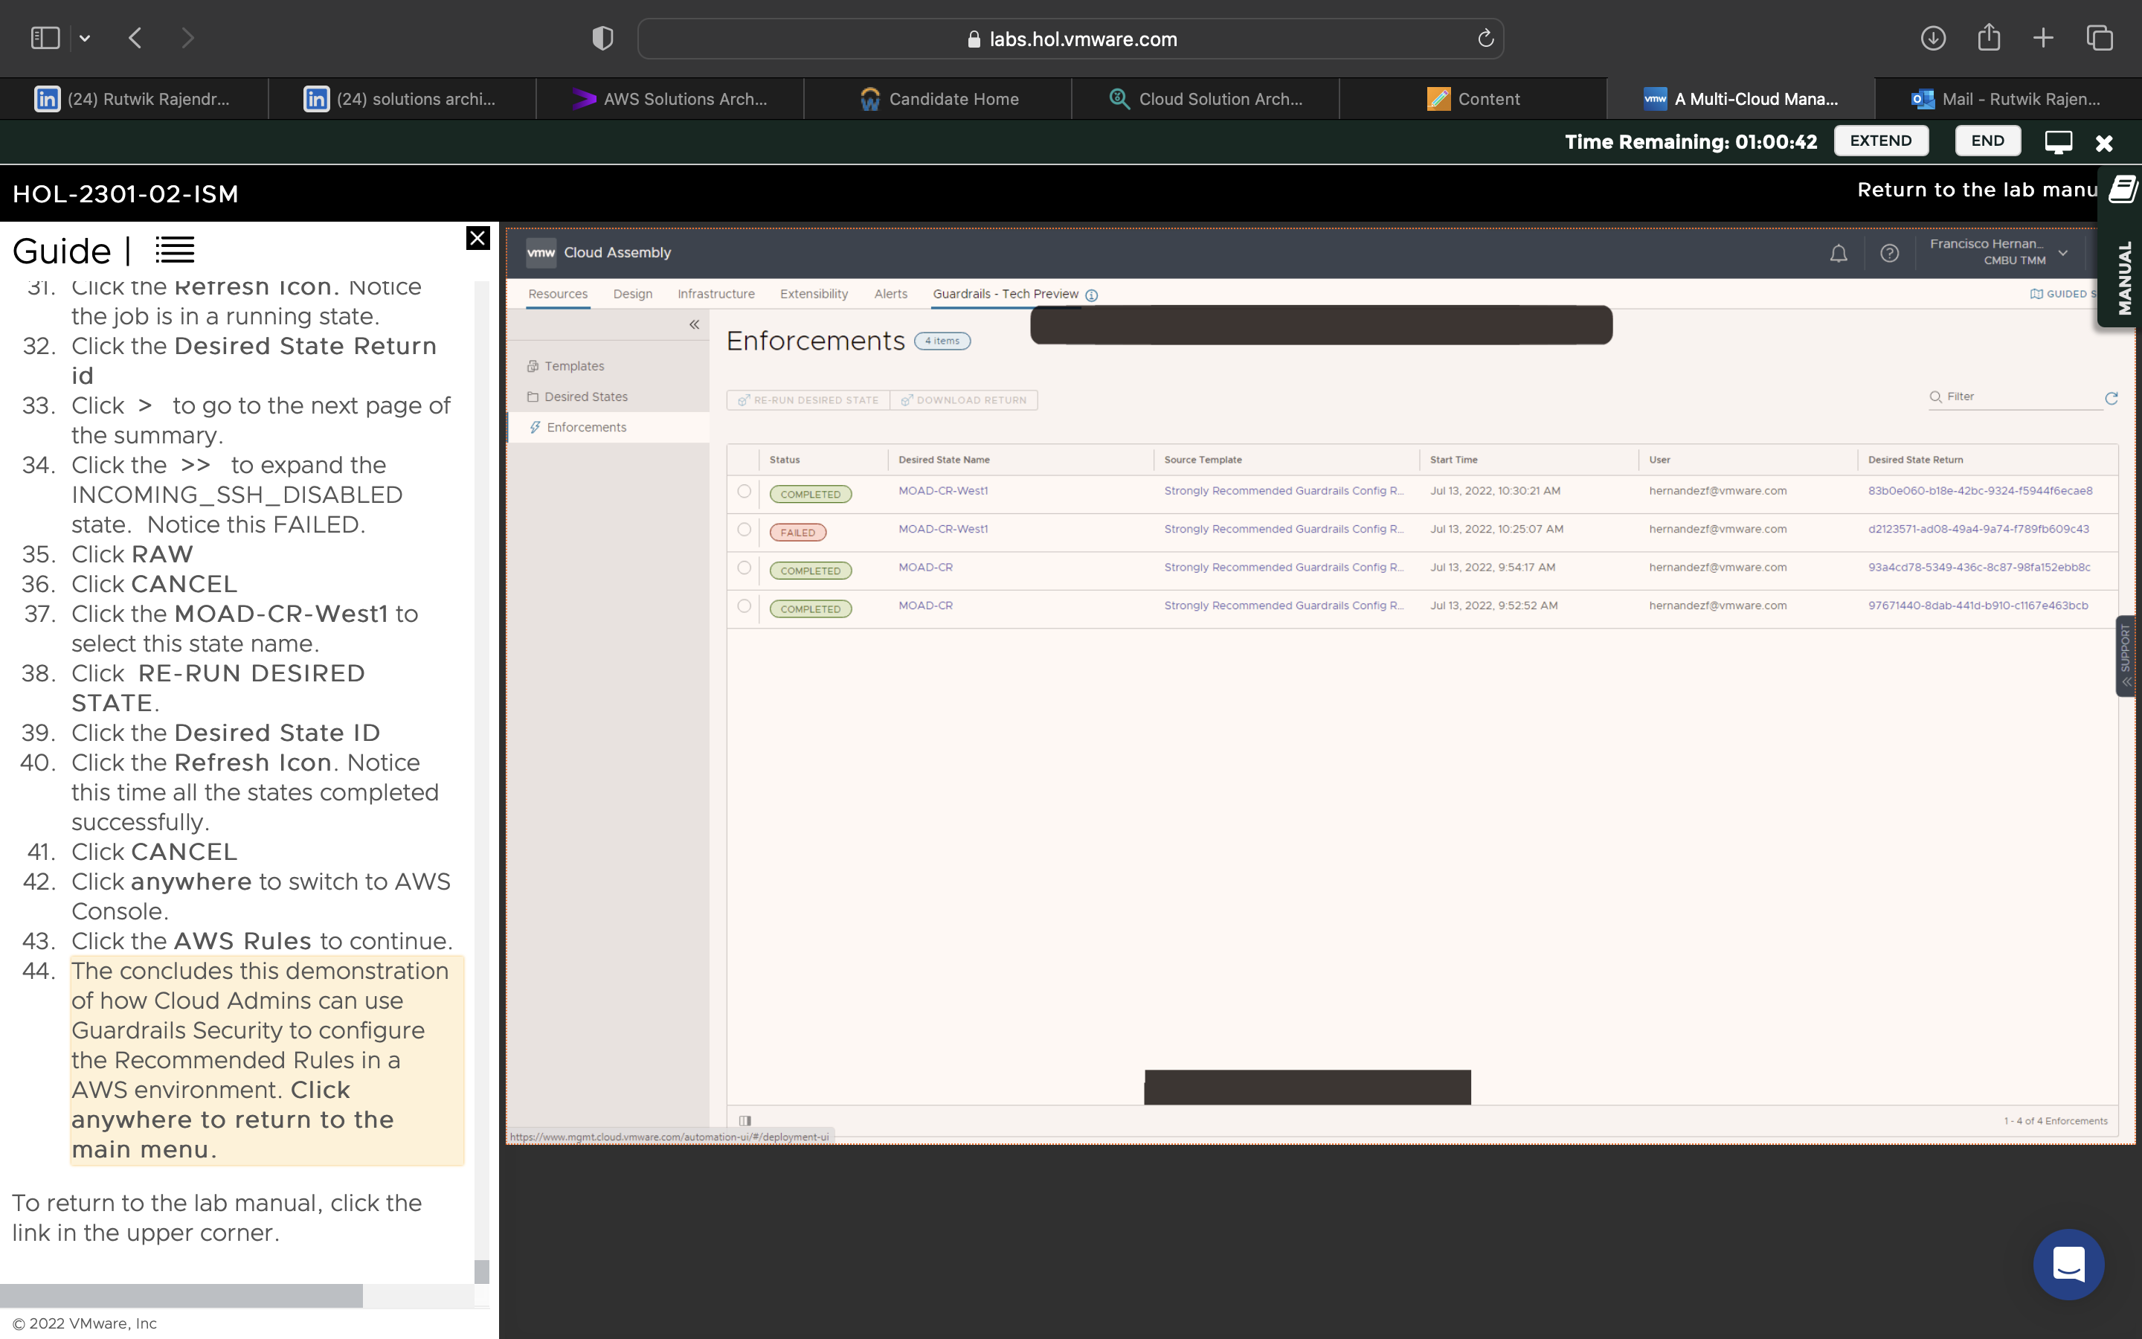

Created a no public IP rule within AWS, used the recommended rules to better security.